**INTRODUCTION**

DYNAMO - API - DYNAMO PLAYER - VERSIONS - LANGUAGE FUNDAMENTALS

**DYNAMO SANDBOX**

DYNAMO WINDOW -WIRES AND NODES - WATCH - NUMBERS - STRINGS— CODE BLOCK-VARIABLES -DATA MANAGEMENT -OPERATIONS-BOOLEAN - LIST -RANGE-SEQUENCE -CHOP-FLATTEN-TRANSPOSE -LIST LEVEL-COUNT-FILTERBYMASK.

**GEOMETRY**

GEOMETRY - PLANE-VECTOR-COORDINATE SYSTEM -POINT- CURVES -SURFACE- SOLID-MESH- CHORD SEGMENT.

**REVIT DYNAMO**

SELECTION- IMPORT REVIT- IMPORT AND EXPORT EXCEL -IMPORT CAD–CREATE LEVELS -CREATE GRID – CREATE LINE BASED SYSTEM-CREATE ROOM/SPACE – ADOPTIVE COMPONENT-GET AND SET PARAMETERS -IMPORT INSTANCE-BY GEOMETRY-CREATE SHEET.

**PACKAGES**

ADD PACKAGES – SEARCH PACKAGES-DOWNLOAD PACKAGE ZIP- PACKAGES MANAGEMENT.

**MODIFY**

NODE STATUS– KEYBOARD SHORTCUTS- UNWRAP – NODE GROUP AND WRITE NOTE

- USE LEVELS-LACING

**DESIGN SCRIPT- (ADVANCE LEVEL)**

INTRODUCTION OF CODE BLOCK SCRIPT- PYTHON SCRIPT.

**INTRODUCTION**

***1.0 WHAT IS DYNAMO?***

Dynamo is an open source tool and it extends the power of Revit by providing access to the Revit API (**A**pplication **P**rogramming **I**nterface) in a more accessible manner. Rather than typing code, with Dynamo you create programs by manipulating graphic elements called “nodes”. It’s an approach to programming better suited for visually oriented types, like architects, designers, and engineers.

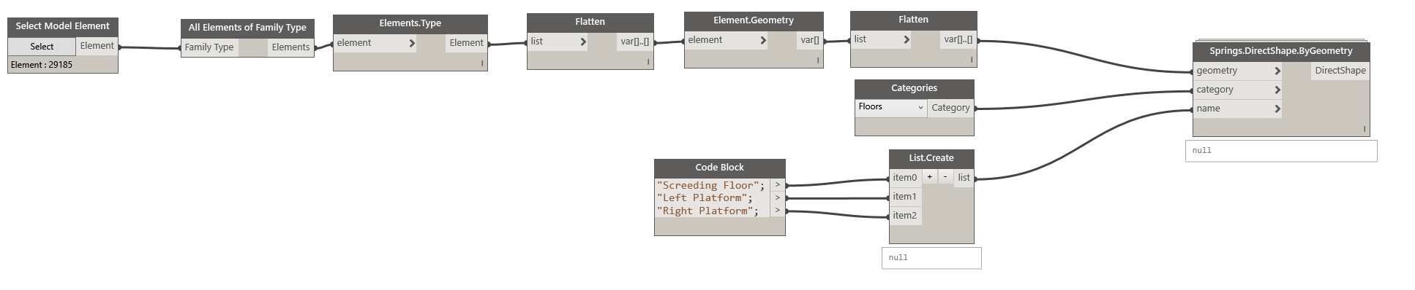

*Fig. 1.0*

In Dynamo, each node performs a specific task. Nodes have inputs and outputs. The outputs from one node are connected to inputs on another using “Wires”. The program or “Graph” flows from node to node through the network of wires. The result is a graphic representation of the steps required to achieve the end design.

* 1. **API (Application Programming Interface)**

An application programming interface (API) allows users and developers to extend the capabilities of an existing application by writing a program or script that adds new functionality to the software. The Autodesk Revit API allows programmers to change elements in the Building Information Model (BIM) directly or to access the data to perform specialized tasks. Power users and software developers are taking advantage of the Revit API to create their own custom tools. By using the Revit API, they are able to enhance Revit’s power to improve work- flows and create better building designs faster. 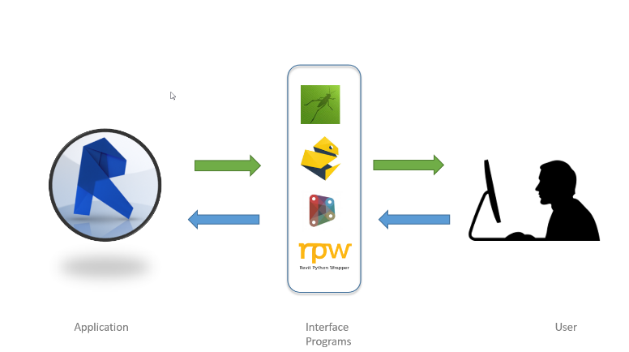 *Fig 1.1*

* 1. **DYNAMO PLAYER**

Dynamo Player provides a simpler way to execute Dynamo scripts in Revit, when opened, the Dynamo Player displays a list of Dynamo scripts in a specified directory.

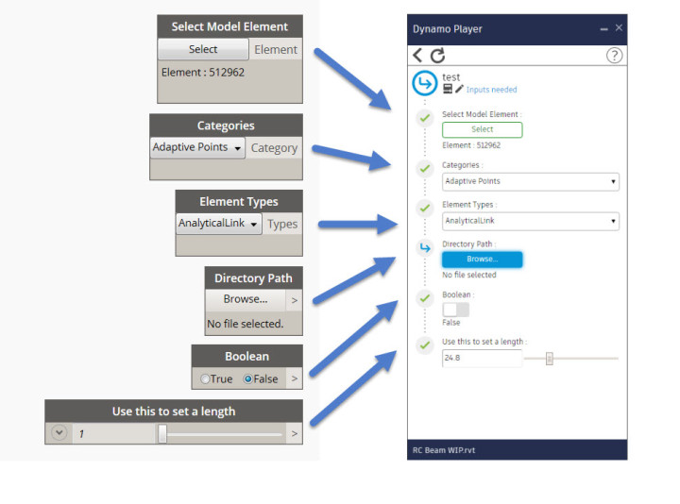

*Fig 1.2*

Dynamo Player provides

* Default script directory selection
* Filtering visible scripts
* Viewing current script status
* Launching the script
* Editing the script in Dynamo

To use Dynamo Player, click Manage tab  Visual Programming panel   (Dynamo Player).

* 1. **VERSIONS**

As both Revit and dynamo continue to evolve, you may notice that the Revit version you are working with is not compatible with the dynamo for Revit version you have installed on your machine. Below outline which versions of dynamo for Revit are compatible with Revit.

* Check your dynamo version,

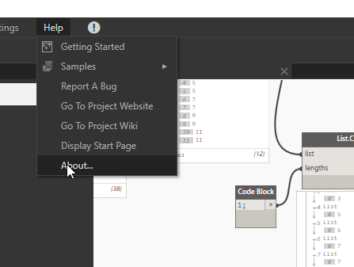

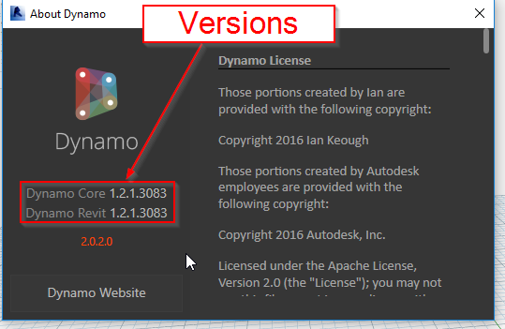

*Fig 1.2*

* Dynamo versions are compatible with Revit version

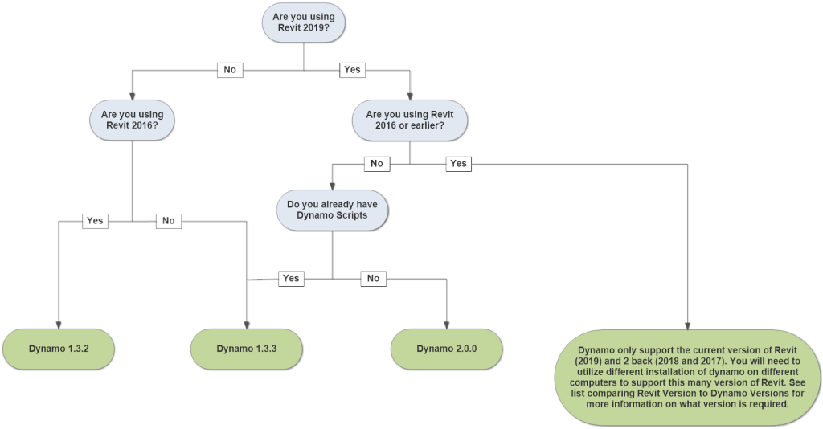

*Fig. 1.3*

|  |  |
| --- | --- |
| **Revit Version** | **Dynamo Version** |
| 2013 | 0.6.3 |
| 2014 | 0.8.2 |
| 2015 | 1.2.1 |
| 2016 | 1.3.2 |
| 2017 | Current 1.3.3 or 2.0.0 |
| 2018 | Current 1.3.3 or 2.0.0 |
| 2019 | Current 1.3.3 or 2.0.0 |

* 1. **LANGUAGE FUNDAMENTALS**

Programming languages are created to express ideas, usually involving logic and calculation. All programs are composed of two items: Data and Operations on that Data. Because, at their heart, computers are simple devices, they can only represent very simple pieces of information. All complex information must be built up from these basic Data Types.

**Basic Data Types:**

* Integer
* Float
* String
* Boolean
* List
* Dictionary
* None

*Integer:*

Positive or negative whole numbers with no decimal points

{5} {-10} {300}

*Float:*

Positive or negative Integer values, with decimals separated by a dot.

{1.0} {0.002} {-0.001}

*String:*

A string is a data type used in programming, such as an integer and floating point unit, but is used to represent text rather than numbers. It is comprised of a set of characters that can also contain spaces and numbers.

“Dynamo extension is dyn”

“Wood with Patches”

“TXT1”

*Boolean:*

Valid Boolean-type values are True and False. These types are case sensitive, so True is not the

same as true.

* True
* False

*None:*

None is a unique object type that’s used to represent an undefined value or the absence of a value.

**Expressions and Statements:**

Expression are statements that make up the core syntactical structure of the language. You do not have to memorize these, but knowing them helps form a vocabulary that can be used to better understand and discuss a language.

*Expressions:*

An expression is a combination of values and operators that can be evaluated down to a single value or object. Some examples are:

2*2 = 4

“dynamo” + “BIM” = dynamoBIM

23>52= false

*Statements:*

In contrast, statements are basically everything else, often associated with an action. Common statements are variable assignment (x = 2), and other flow-control features such as (if, else, for, etc.).

x = 3

if x==3:

x=5

*Statement – Assignment:*

A single ‘=’ symbol is used to assign a value to a variable name. This is different than two ‘==’, which is a check for equality, as shown above.

X = 1

y = 3

*Statement – Conditional:*

If, else, and elif can be used to check for conditions, and control the flow of the program based on whether those conditions are met

x = 5

if x>3:

print(‘x is larger than 3’)

elif x == 3

print(‘x is 3’)

else:

print(‘x is less than 3’)

*Statement - For Loop:*

For Loops allow us to iterate over any iterable elements. Some of the most common iterables elements are Lists, Dictionaries, Strings:

for letter in ‘hello’:

print(letter)

‘h’

‘e’

‘l’

‘l’

‘o’

for number in [1,2,3]:

print(number)

‘1’

‘2’

‘3’

**DYNAMO STANDBOX**

**2.1 DYNAMO WINDOW**

To launch Dynamo, browse to \Program Files\Dynamo\Dynamo Revit\x.y, then select DynamoSandbox.exe. This will open the stand-alone(SANDBOX) version and present Dynamo's Start Page. On this page, we see the standard menus and toolbar as well as a collection of shortcuts that allow us to access file functionality or access additional resources.

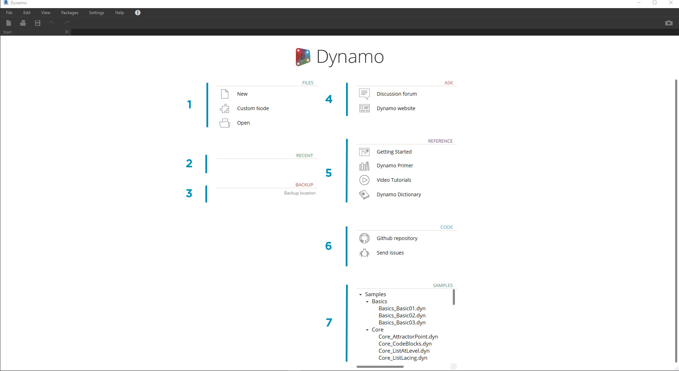

*Fig 2.1*

1. Files - Start a new file or open an existing one
2. Recent - Scroll through your recent files
3. Backup - Access to your backups
4. Ask - Get direct access to the User Forum or Dynamo Website
5. Reference - Go further with additional learning resources
6. Code - Participate in the open-source development project
7. Samples - Check out the examples that come with the installation

The User Interface (UI) for Dynamo is organized into five main regions, the largest of which is the workspace where we compose our visual programs. 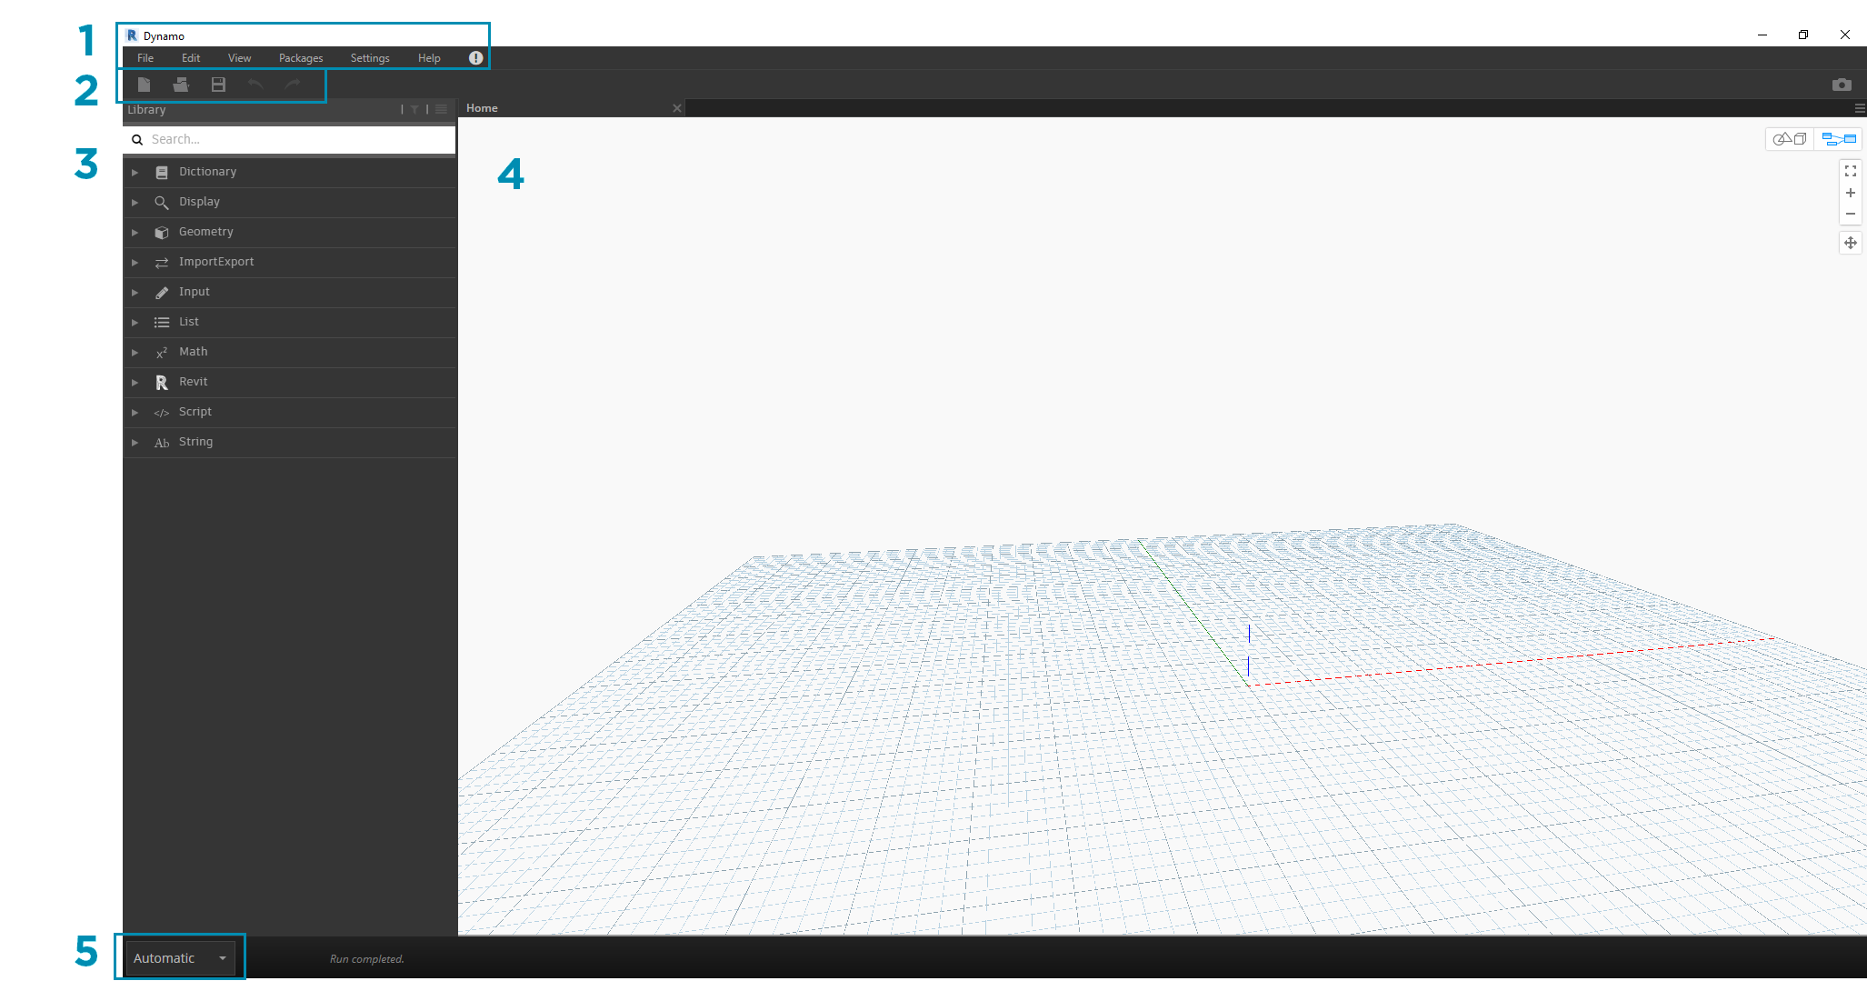

*Fig 2.2*

1. Menus
2. Toolbar
3. Library
4. Workspace
5. Execution Bar

Let's dive deeper into the UI and explore the functionality of each region.

**2.1.1 Menus**

The Dropdown Menus are a great place to find some of the basic functionality of the Dynamo application. Like most Windows software, actions related to managing files and operations for selection and content editing are found in the first two menus. The remaining menus are more specific to Dynamo.

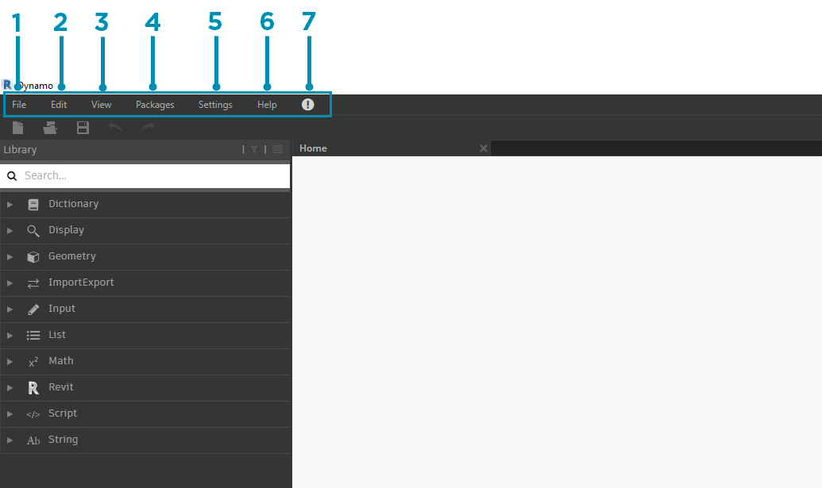

*Fig 2.3*

1. File
2. Edit
3. View
4. Packages
5. Settings
6. Help
7. Notifications

**2.1.2 Toolbar**

Dynamo's Toolbar contains a series of buttons for quick access to working with files as well as Undo [Ctrl + Z] and Redo [Ctrl + Y] commands. On the far right is another button that will export a snapshot of the workspace, which is extremely useful for documentation and sharing.

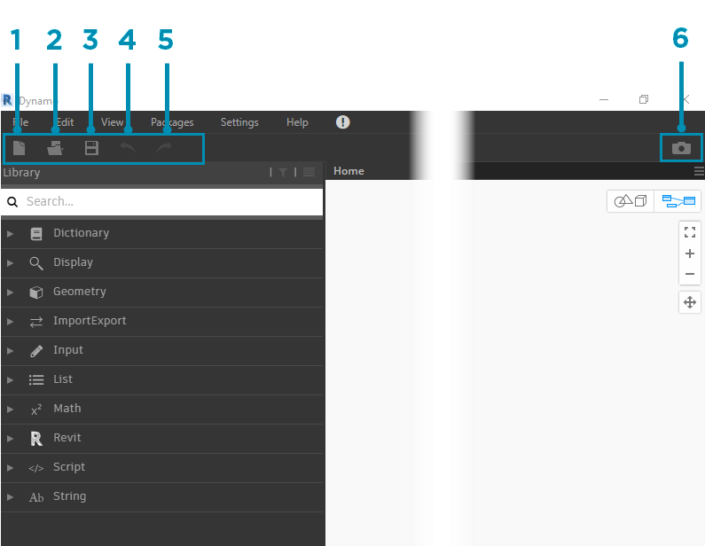

*Fig 2.4*

1. New - Create a new .dyn file
2. Open - Open an existing. dyn (workspace) or .dyf (custom node) file
3. Save/Save As - Save your active .dyn or .dyf file
4. Undo - Undo your last action
5. Redo - Redo the next action
6. Export Workspace as Image - Export the visible workspace as a PNG file

**2.1.3 Library**

The Library contains all of the loaded Nodes, including the default Nodes that come with the installation as well as any additionally loaded Custom Nodes or Packages. The Nodes in the Library are organized hierarchically within libraries, categories, and, where appropriate, sub-categories based on whether the Nodes **Create** data, execute an **Action**, or **Query** data.

***Browsing***

By default, the **Library** will contain eight categories of Nodes. **Core** and **Geometry** are great menus to begin exploring as they contain the largest quantity of Nodes. Browsing through these categories is the fastest way to understand the hierarchy of what we can add to our Workspace and the best way to discover new Nodes you haven't used before.

We will focus on the default collection of Nodes now, but note that we will extend this Library with Custom Nodes, additional libraries, and the Package Manager later.

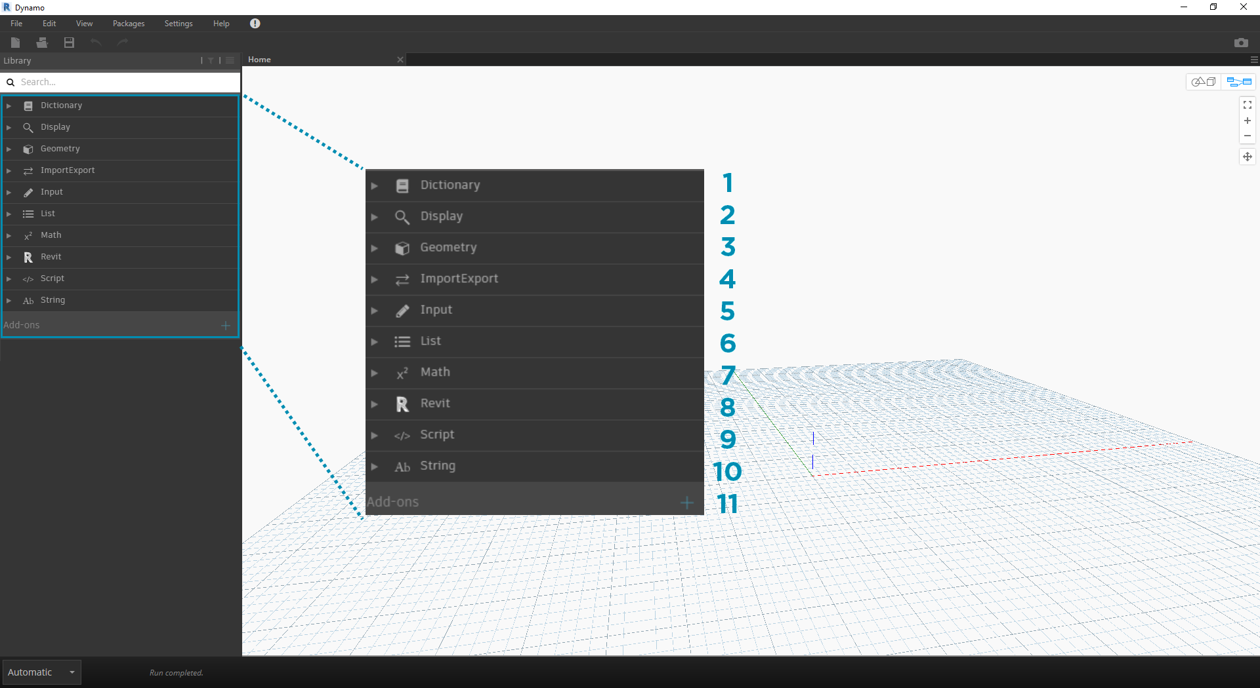

*Fig 2.5*

1. Dictionary
2. Display
3. Geometry
4. Import-Export
5. Input
6. List
7. Matches
8. Revit
9. Script
10. String
11. Add-ons

Browse the Library by clicking through the menus. Click the Geometry > Curves > Circle. Note the new portion of the menu that is revealed and specifically the **Create** and **Query** Labels.

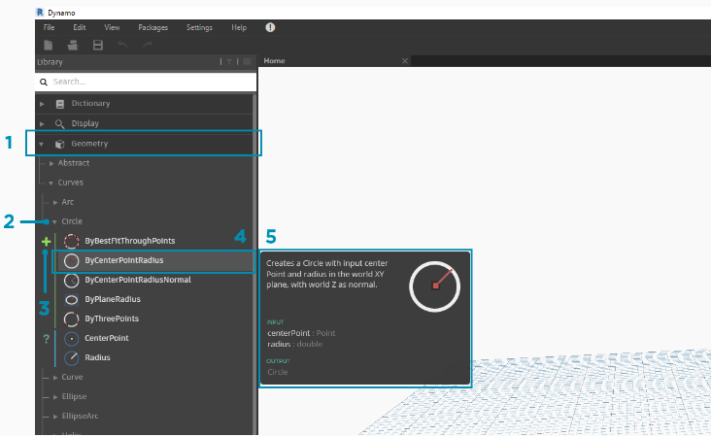

*Fig 2.6*

1. Library
2. Category
3. Subcategory: Create/Actions/Query
4. Node
5. Node Description and properties - this appears when hovering over the node icon.

From the same Circle menu, hover your mouse over **ByCenterPointRadius**. The window reveals more detailed information about the Node beyond its name and icon. This offers us a quick way to understand what the Node does, what it will require for inputs, and what it will give as an output.

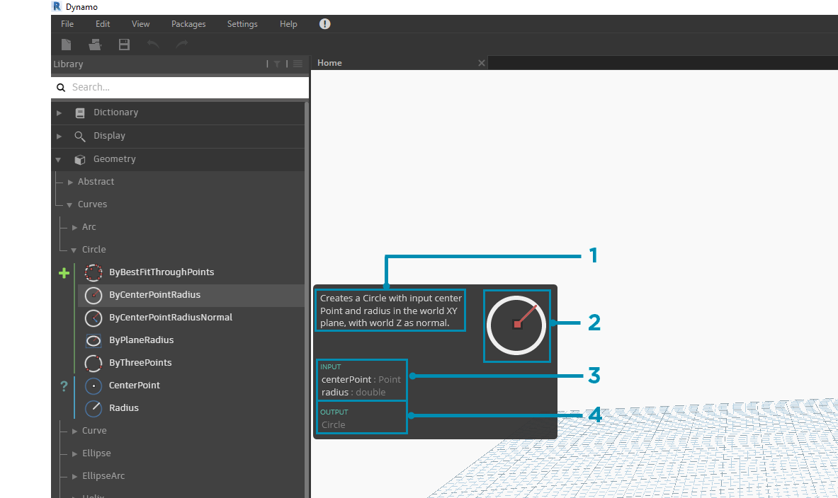

*Fig 2.7*

1. Description - plain language description of the Node
2. Icon - larger version of the icon in the Library Menu
3. Input(s) - name, data type, and data structure
4. Output(s) - data type and structure

***Searching***

If you know with relative specificity which Node you want to add to your Workspace, the **Search** field is your best friend. When you are not editing settings or specifying values in the Workspace, the cursor is always present in this field. If you start typing, the Dynamo Library will reveal a selected best fit match (with breadcrumbs for where it can be found in the Node categories) and a list of alternate matches to the search. When you hit Enter, or click on the item in the truncated browser, the highlighted Node is added to the center of the Workspace.

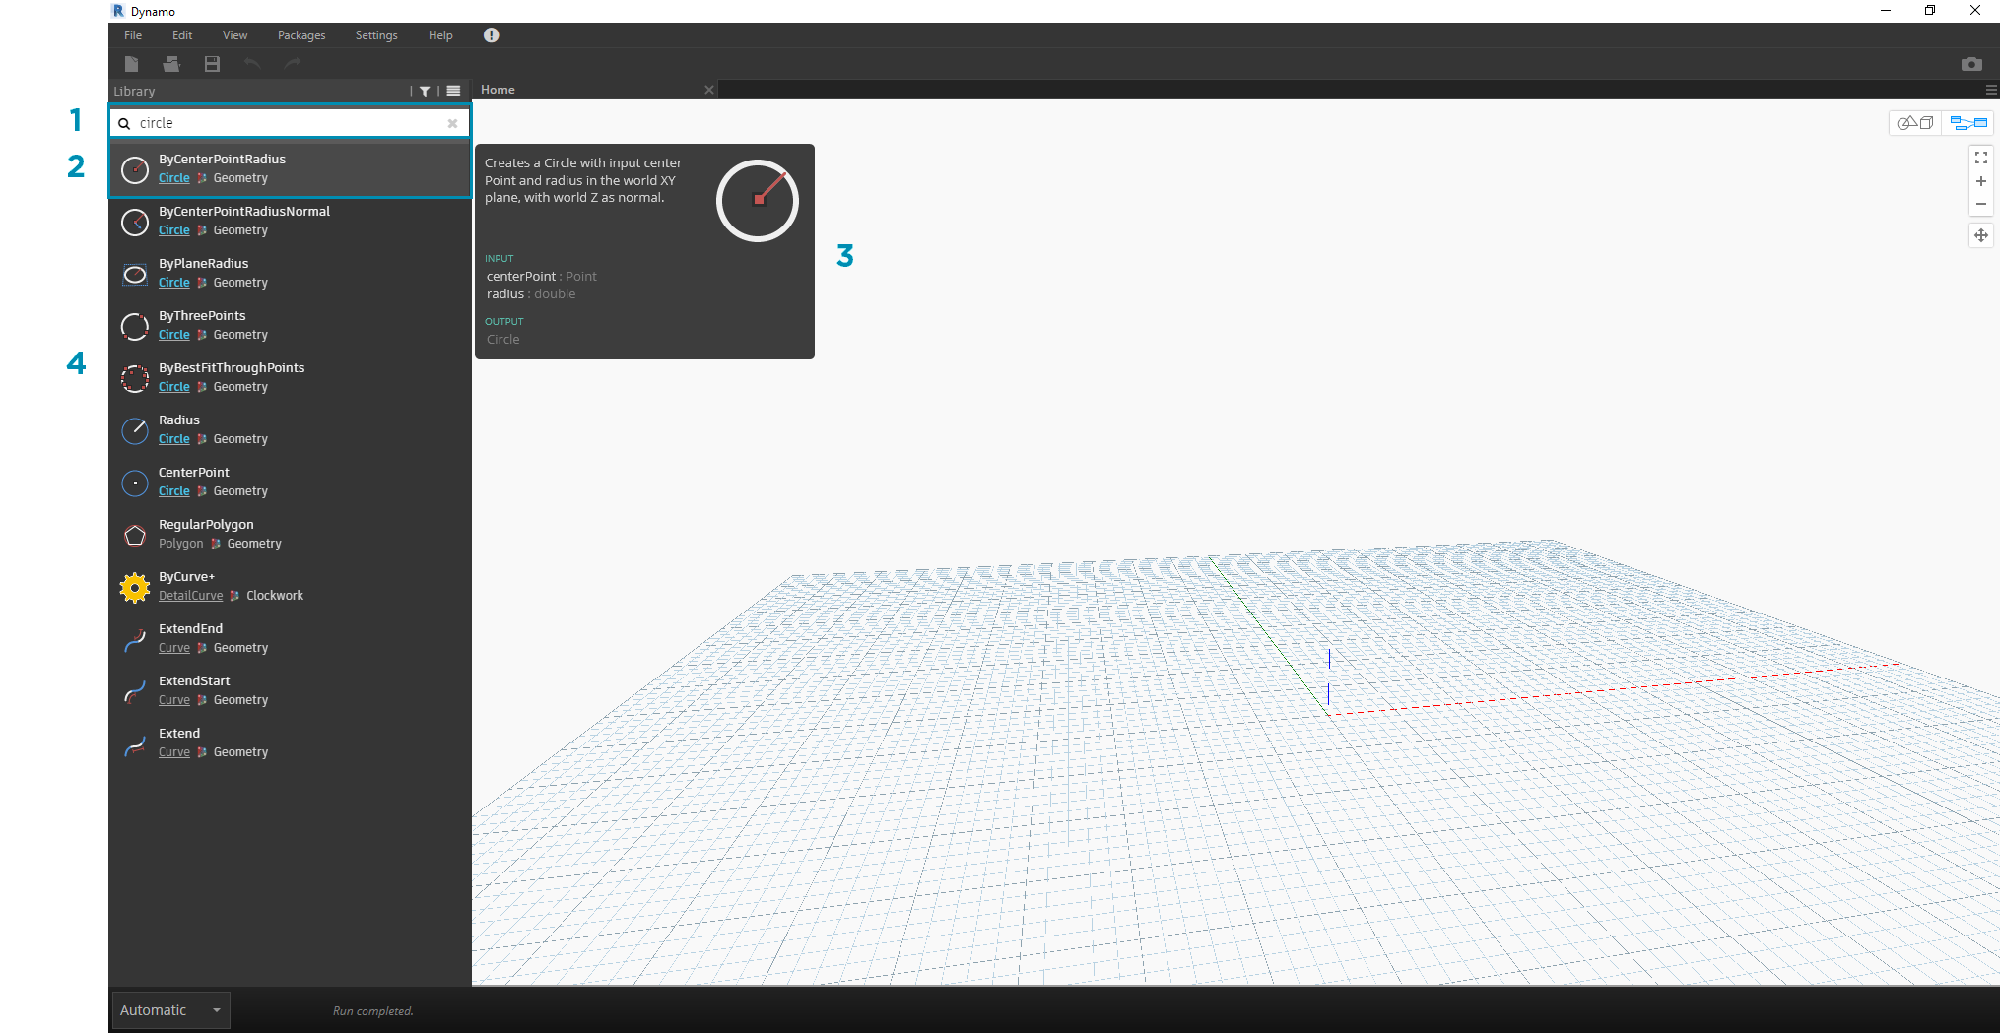

*Fig 2.8*

1. Search Field
2. Best Fit Result / Selected
3. Alternate Matches

***Settings***

From geometric to user settings, these options can be found in the **Settings** menu. Here you can opt in or out for sharing your user data to improve Dynamo as well as define the application's decimal point precision and geometry render quality.

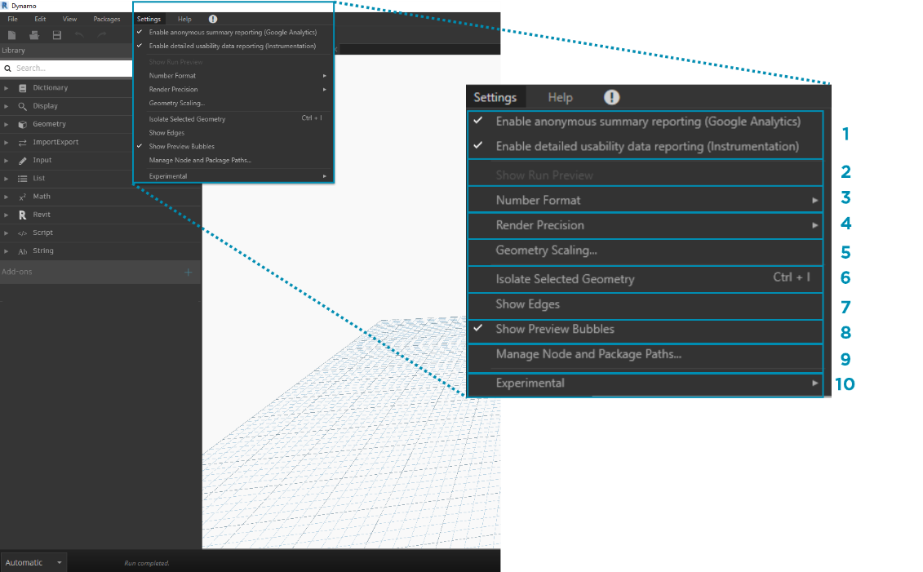

*Fig 2.9*

1. Enabling Reporting - Options for sharing user data to improve Dynamo.
2. Show Run Preview - Preview the execution state of your graph. Nodes scheduled for execution will be highlighted in your graph.
3. Number Format Options - Change the document settings for decimals.
4. Render Precision - Raise or lower the document render quality.
5. Geometry Scaling - Select range of geometry you are working on.
6. Isolate Selected Geometry - Isolated background geometry based on your node selection.
7. Show/Hide Geometry Edges - Toggle 3D geometry edges.
8. Show/Hide Preview Bubbles - Toggle data preview bubbles below nodes.
9. Manage Node and Package Paths - Manage file paths to make nodes and packages show up in the Library.
10. Enabling Experimental Features - Use beta features new in Dynamo.

***Help***

If you're stuck, check out the **Help** Menu. Here you can find the sample files that come with your installation as well as access one of the Dynamo reference websites through your internet browser. If you need to, check the version of Dynamo installed and whether it is up to date through the **About** option.

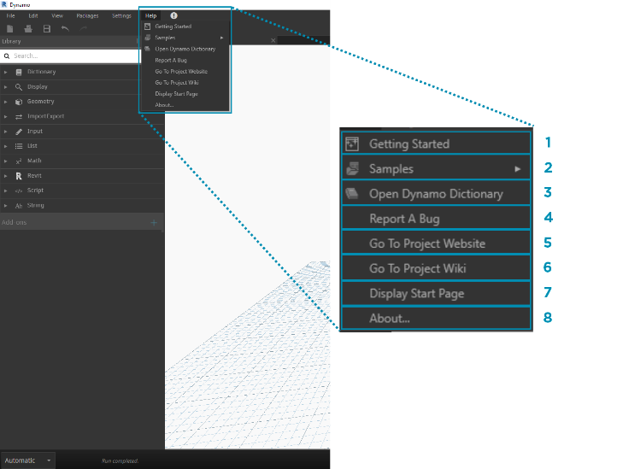

*Fig 2.10*

1. Getting Started - A brief introduction to using Dynamo.
2. Samples - Reference example files.
3. Open Dynamo Dictionary - Resource with documentation on all nodes.
4. Report A Bug - Open an Issue on GitHub.
5. Go to Project Website - View the Dynamo Project on GitHub.
6. Go to Project Wiki - Visit the wiki for learning about development using the Dynamo API, supporting libraries and tools.
7. Display Start Page - Return to the Dynamo start page when within a document.
8. About - Dynamo Version data.
   1. **NODES AND WIRES**

Nodes are the objects you connect to form a Visual Program. Each Node performs an operation - sometimes that may be as simple as storing a number or it may be a more complex action such as creating or querying geometry.

Wires connect between Nodes to create relationships and establish the Flow of our Visual Program. We can think of them literally as electrical wires that carry pulses of data from one object to the next.

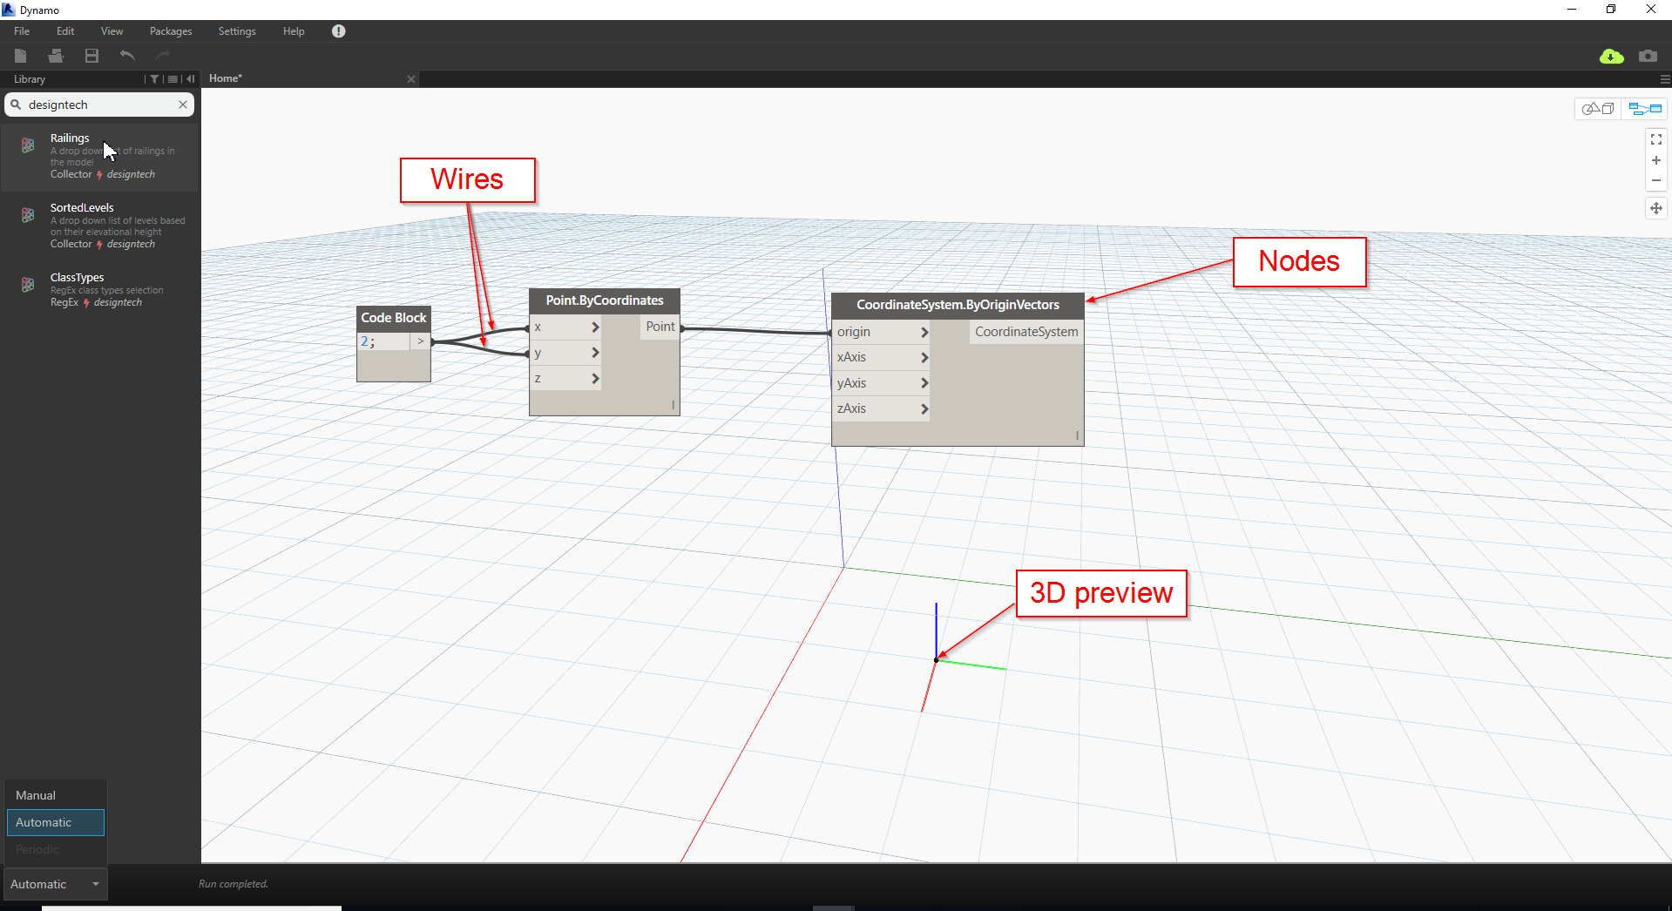

*Fig 2.11*

* 1. **STRING**

A String is a sequence of characters representing a literal constant or some type of variable. Informally, a string is programming lingo for text. We've worked with numbers, both integers and decimal numbers, to drive parameters and we can do the same with text.

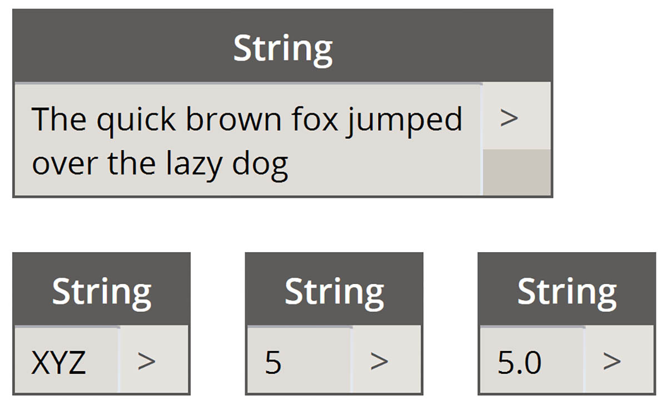

*Fig 2.12*

* 1. **CODE BLOCK**

A Code Block will automatically generate Input ports and output ports based upon the code authored within. Output ports are generated by terminating a line of code with a semi-colon ( ; ):

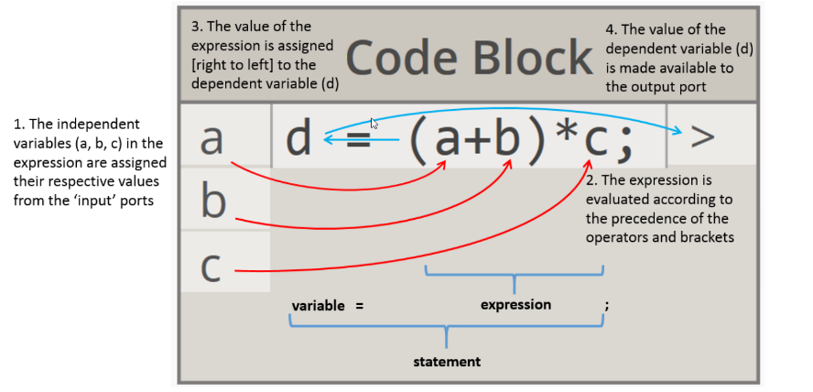

*Fig 2.13*

d = Our named variable.

a | b | c = Undefined variables become input ports.

= Output ports are generated at the end of every line of code.

The value of the expression is assigned right-to-left to the variable.

The expression is evaluated according to the precedence of the operators

and brackets.

**2.5.1 STRINGS**

String - Design Script for ‘Text’. Enclose inside of quotation marks:

str = “Quotation marks to create a String.”

multiLineStr = “We can use ‘return’ to split up our string

which allows your text to span across multiple lines ( i.e. it wraps )!!!”;

You can cast (Change the type of) any object to a String by concatenating empty quotations to that type:

lne = Point.ByCoordinates();

strLne = lne + "";

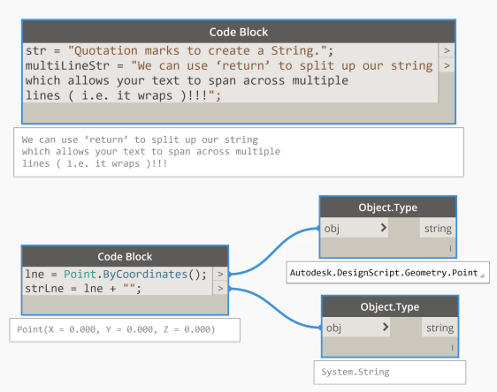

*Fig 2.14*

Note: There is a graphical inconsistency with the wrapped line text that fails to

colour the subsequent lines. The code will correctly execute however.

Not to be confused with text objects inside of Revit

**2.5.2 NUMBERS**

Int (Integer ) - Whole number:

intVar = 10;

Double ( Float / Number ) - Decimal placed number:

doubleVar = 20.27;

As both int and double are reserved keywords we can’t use them as variable names.Code Blocks only return the final result of the line of code (As shown in the image exemplar ).

You can cast (Change the type of) a String representation of a number to a number using:

String.ToNumber(number );

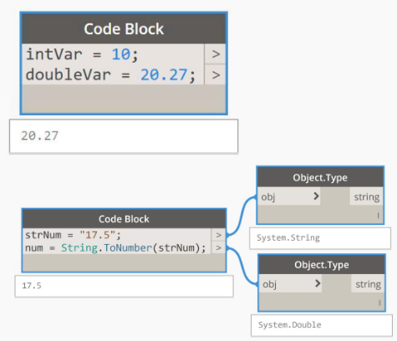

*Fig 2.15*

**2.5.3 VARIABLES**

Variable - They act like containers that hold information, callable by their name*:

str = “BILT EUR “;

num = 2018;

combined = str + num;

Assign using the variableName = data syntax.

Variables are used to store information in memory to then be referenced and manipulated in DesignScript.

They allow us to label data with a descriptive name to make sense of our code. They provide clarity when others read your code (If you are diligent at naming!).

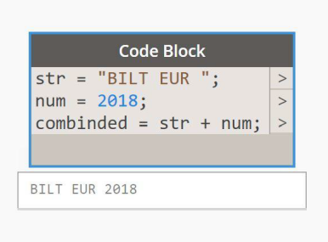

*Fig 2.16*

Note: You can assign a variable to another variable.

Using concatenation, you have to account for the spaces yourself (Refer to example image).

*Variables are not global. They are local to their own Code Block.

* 1. **Data Management**

In the Data Management section, we will cover the following: Replication, List@Level, Nesting and Conflicts.

*Concepts*

DesignScript allows for the use of functions as arguments. For example you can call two Point.ByCoordinates() functions inside of a Line.ByStartPointEndPoint(). To call a function multiple times inside a singular Code Block you would want to write each function on its own line:

startPoint = Point.ByCoordinates( );

endPoint = Point.ByCoordinates(10, 0, 0);

newLine = Line.ByStartPointEndPoint( startPoint, endPoint );

However, if the function will not be called more than once, you can write your code more

concisely by calling the function directly inside of another function:

newLine = Line.ByStartPointEndPoint( Point.ByCoordinates( ),

Point.ByCoordinates( 10, 0, 0 ) );

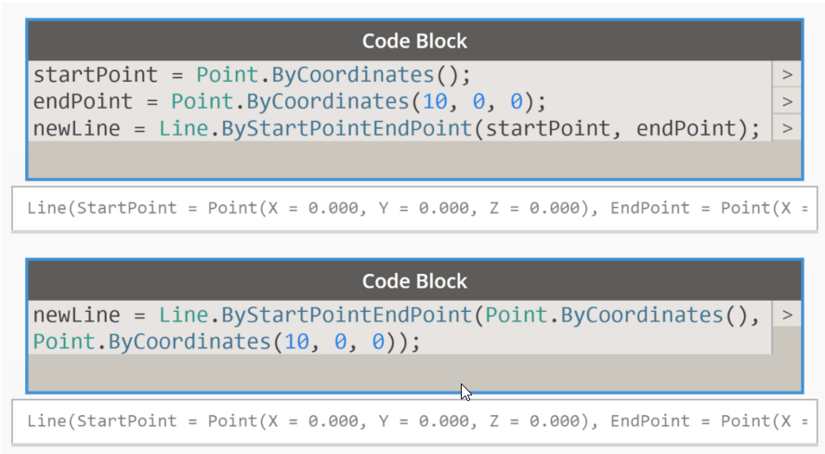

*Fig 2.17*

firstItem = list[ 0 ]; longestLacing = list01<1L> + list02<1L>;

lastItem = list[ -1 ]; crossProductLacing = list01<1> + list02<2>;

middleItem = list[ Count(list) / 2 - 1 ]; reversedCrossProduct = list01<2> + list02<1>;

itemRange = list[ 0..3 ]; Surface.PointAtParameter( srf, u, v );

reverseItemRange = list[ -2..-3 ]; srf.PointAtParameter( u, v );

Point.ByCoordinates( x<1>, y<2>, z<3> ); List.Clean( list01 );

shortestLacing = list01<1> + list02<1>; DSCore.List.Clean( list01 );

start..amount..step; start..#amount..step;

start..end..step; start..end..#amount;

start..end..~approximate;

**2.7 Operators**

Operators are a set of components that use algebraic functions with two numeric input values, which result in one output value (addition, subtraction, multiplication, division, etc.).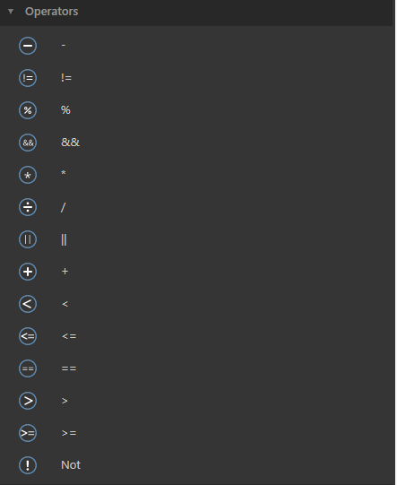

**Arithmetic Operator**s

“+” 🡺 Additional : The ‘+’ operator adds two operands. For example, x+y.

“-”🡺 Subtractions : The ‘-‘ operator subtracts two operands. For example, x-y.

“/”🡺 Divisions : The ‘/’ operator divides the first operand by the second. For example, x/y.

“*”🡺Multiplications : The ‘*’ operator multiplies two operands. For example, x*y.

“%”🡺 Modulus : The ‘%’ operator returns the remainder when first operand is divided by the second. For example, x%y.

Fig 2.18

**Relational Operators**

“==” 🡺 Equal to: The “==” operator checks the relationship between two operands is Equal or not. If the relation is true returns true or false returns false.

“ !=“🡺 Not Equal to: The “!=” operator checks the relationship between two operands is Equal or not. If the relation is true returns false or false returns true.

“>”🡺 Grater than: The “>” operator checks the relationship between two operands is Greater than or not. If the relation is true returns true or false returns false.

“<”🡺 Less than: The “<” operator checks the relationship between two operands is Less than or not. If the relation is true returns true or false returns false.

“>=”🡺 Greater than or Equal: The “>” operator checks the relationship between two operands is Greater than or Equal. If the relation is true returns true or false returns false.

“<=”🡺 Less than or Equal: The “<” operator checks the relationship between two operands is Less than or Equal. If the relation is true returns true or false returns false.

**Logical Operators**

“&&” Logical AND. True only if all operands are true

If c = 5 and d = 2 then, expression ((c == 5) && (d > 5)) is false.

“||” Logical OR. True only if either one operand is true

If c = 5 and d = 2 then, expression ((c == 5) || (d > 5)) is true.

“!” Logical NOT. True only if the operand is 0

If c = 5 then, expression! (c == 5) is false.

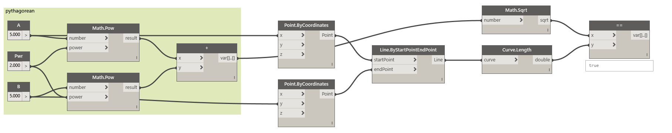

*Fig 2.18*

**2.8 Booleans**

A Boolean expression (or logical expression) evaluates to one of two states true or false. it provides the Boolean type that can be either set to False or True. Many functions and operations return Boolean objects.

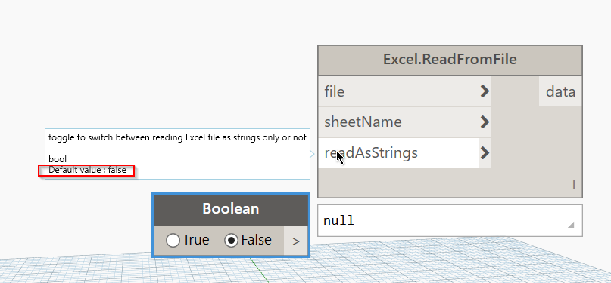

*Fig 2.19*

**2.9 List**

A list is a collection of elements or items in Dynamo, list data is ordered, and the first item in each list has an index "0". Below, we'll discuss how lists are defined in Dynamo and how multiple lists relate to one another.

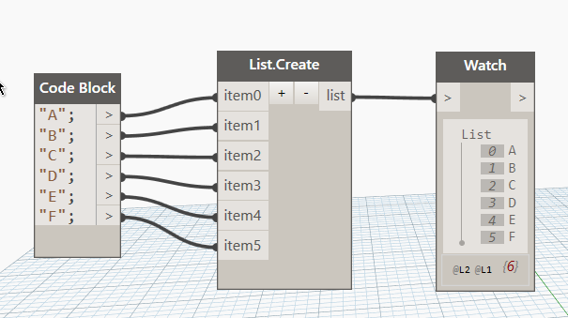

*Fig 2.20*

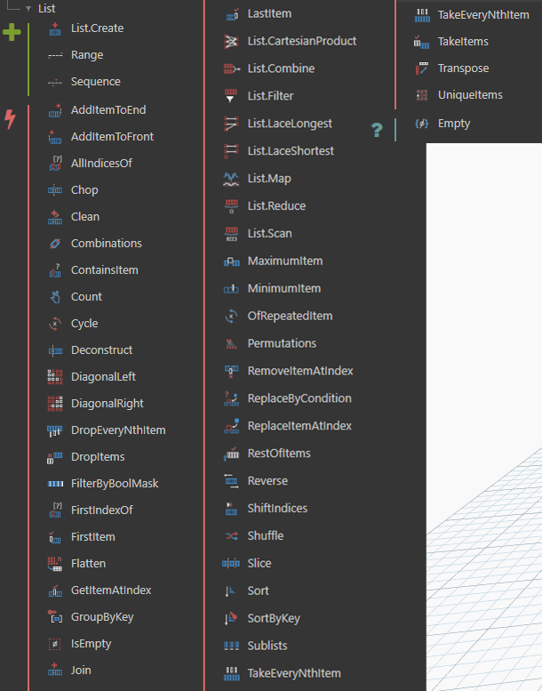

*Fig 2.21*

**2.8 Range**

A Range node defines a list of numbers by using a start, end, and step input. With these nodes’ ranges start from 0 end with 29 and step is 2. i.e (0,2,4, 6...28) .

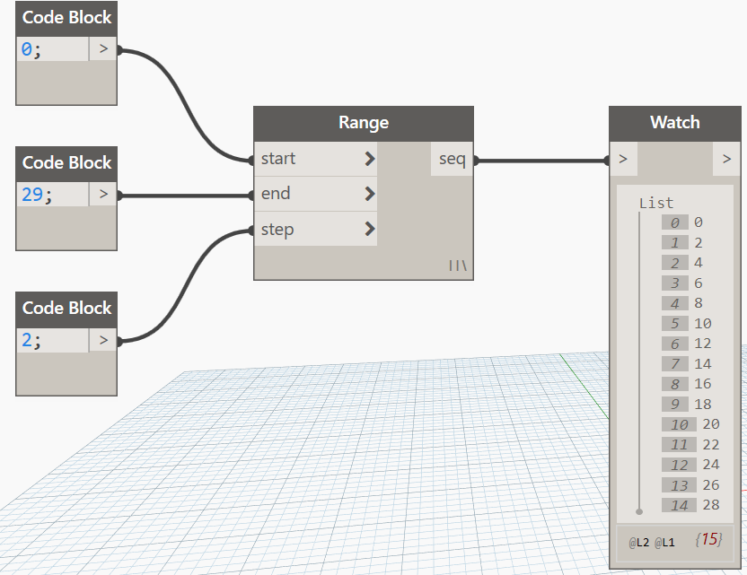

*Fig 2.22*

**2.9 Sequence**

A Sequence node defines a list of numbers by using a start, amount, and step input. With these nodes ranges start from 0 end with 29 and step is 2. i.e (0,2,4, 6,..56).

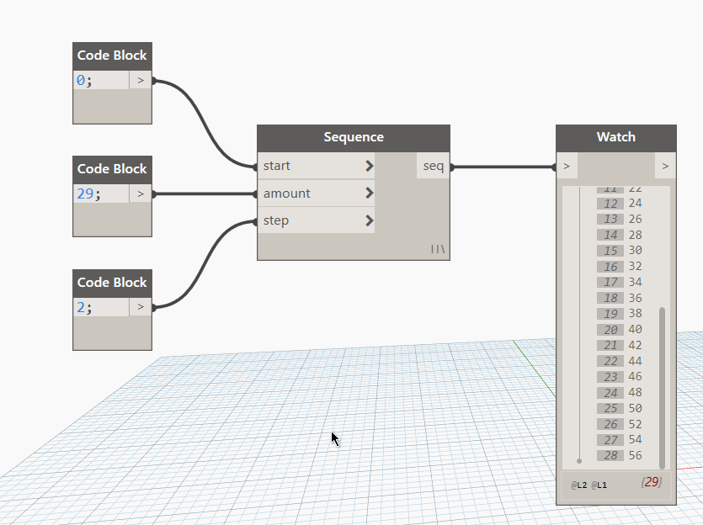

*Fig 2.23*

**Actions**

Actions in list based on the Scenarios in graph and it control the list. for example, if you want the search a string in from list use List.ContainsItem. but here most used nodes discussed because some of nodes necessity is very less, ok however frequently used nodes are below.

**2.10 Chop**

When parametric modeling, there are also times where you'll want to add more data structure to an existing list. There are many nodes available for this as well, and chop is the most basic version. With chop, we can partition a list into sublists with a set number of items.

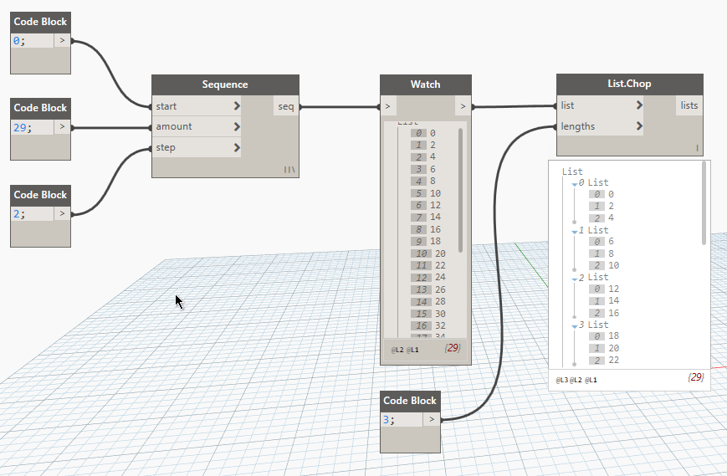

*Fig 2.24*

**2.11 Flatten and List. Flatten**

Flatten removes all tiers of data from a data structure. This is helpful when the data hierarchies are not necessary for your operation, but it can be risky because it removes information. The example below shows the result of flattening a list of data.

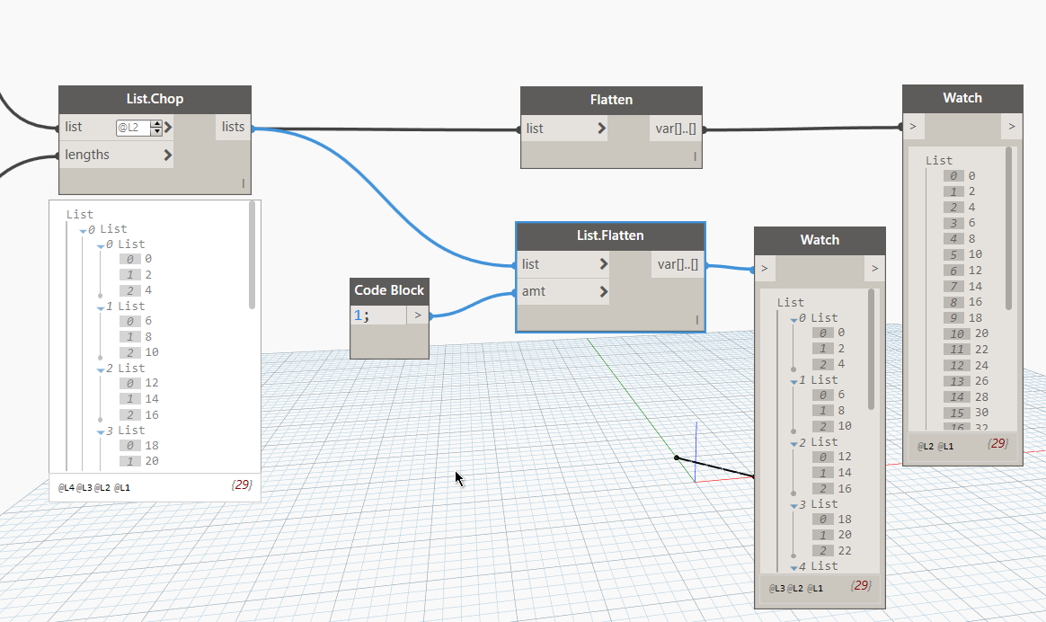

*Fig 2.25*

**2.12 Transpose**

Transpose is a fundamental function when dealing with lists of lists. Just as in spreadsheet programs, a transpose flips the columns and rows of a data structure. We'll demonstrate this with a basic matrix below, and in the following section, we'll demonstrate how a transpose can be used to create geometric relationships.

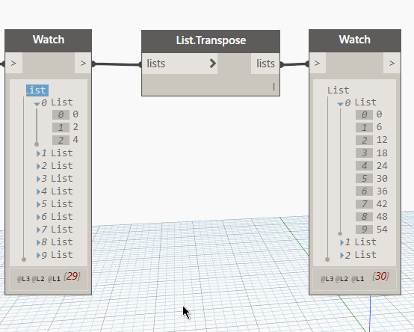

*Fig 2.26*

**List Level**

the List@Level feature allows you to directly select which level of list you want to work with right at the input port of the node. This feature can be applied to any incoming input of a node and will allow you access the levels of your lists quicker and easier than other methods. Just tell the node what level of the list you want to use as the input and let the node do the rest.

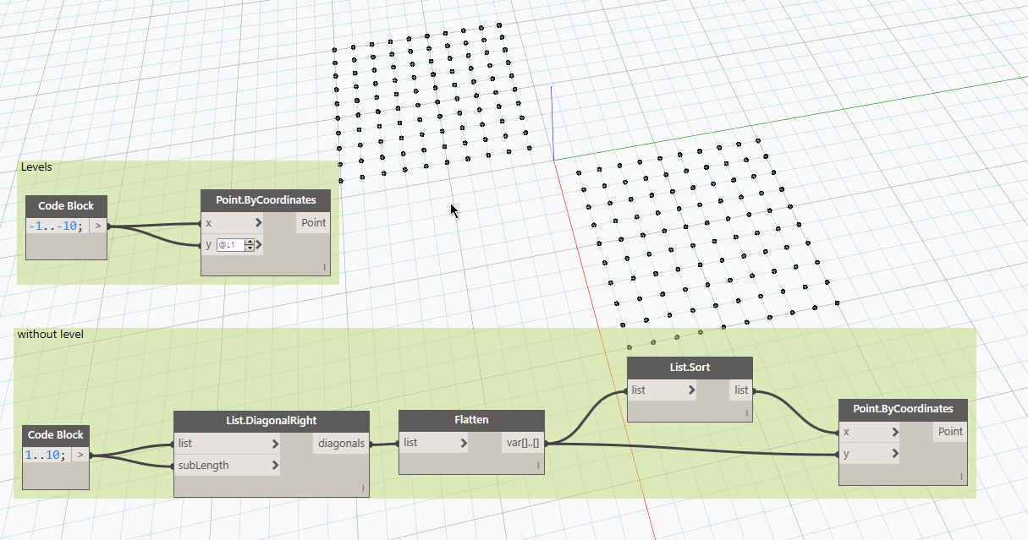

*Fig 2.27*

**2.12 Count**

When a node iterates the list and if you need count it by manually or by Preview bobbles shows a list count but in case level listed or nested list it’s hard to find the count but use the Count node find the number of values in the list and you can use the levels split the count, however the count is used for count the list values.

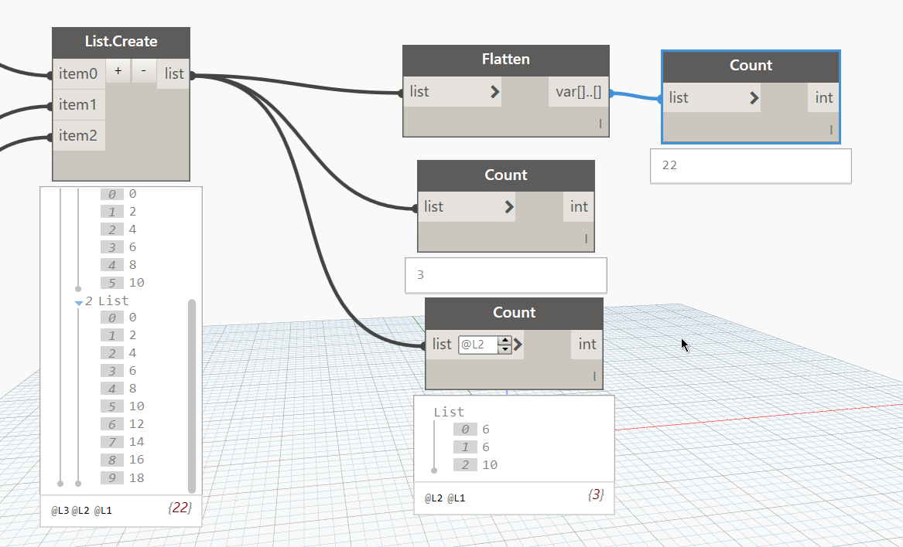

*Fig 2.28*

**Filter by Mask**

This Node mostly used in number of graph because you need to filter or extract something from list by use Boolean. For example, take string A, B and output list have A to Z use the FilterByBoolmask with ListContainsItem you get the values as shown in below fig.

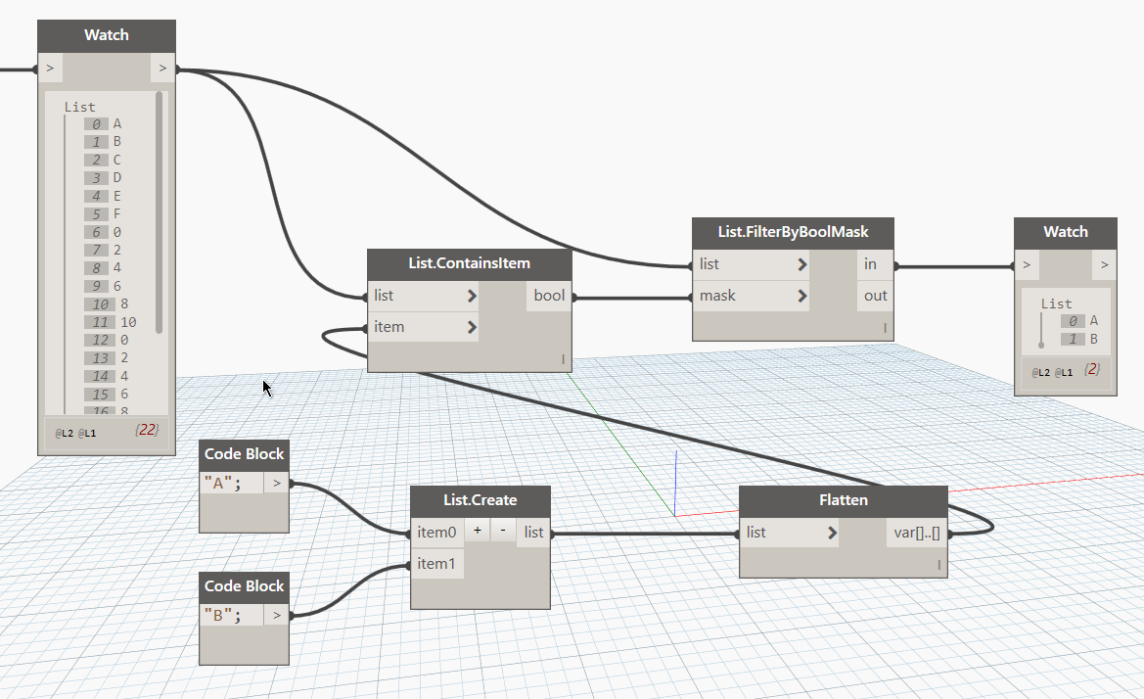

*Fig 2.29*

**Geometry**

**3.1 Geometry**

the Geometry types and how they are related will allow us to navigate the collection of Geometry Nodes available to us in the Library. The Geometry Nodes are organized alphabetically as opposed to hierarchically - here they are displayed similar to their layout in the Dynamo interface.

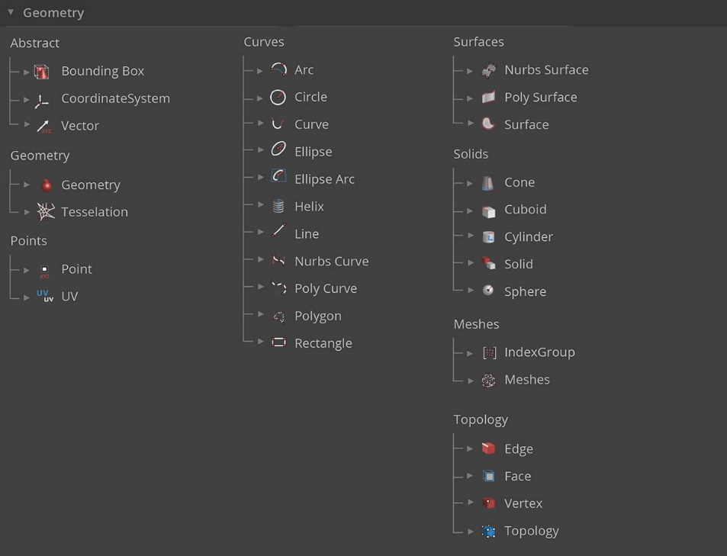

*Fig 3.1*

the Abstract and Hierarchical descriptions of Geometry. Because these two concepts are related, but not always obvious at first, we can quickly arrive at a conceptual roadblock once we start developing deeper workflows or models.

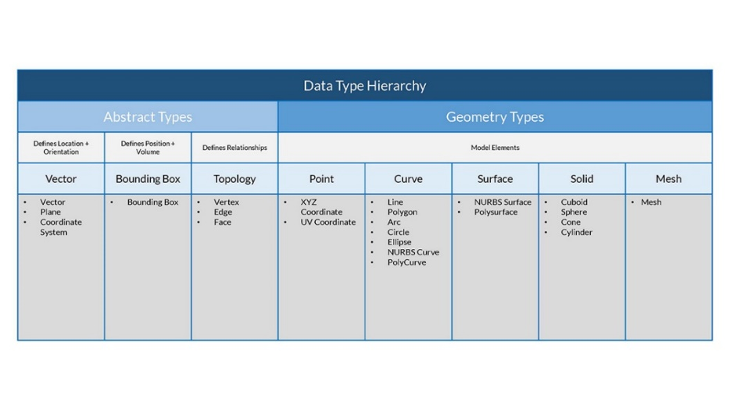

*Fig 3.2*

**3.1 Vector**

A vector is a geometric quantity describing Direction and Magnitude. Vectors are abstract; ie. they represent a quantity, not a geometrical element. Vectors can be easily confused with Points because they both are composed of a list of values. There is a key difference though: Points describe a position in a given coordinate system while Vectors describe a relative difference in position which is the same as saying "direction."

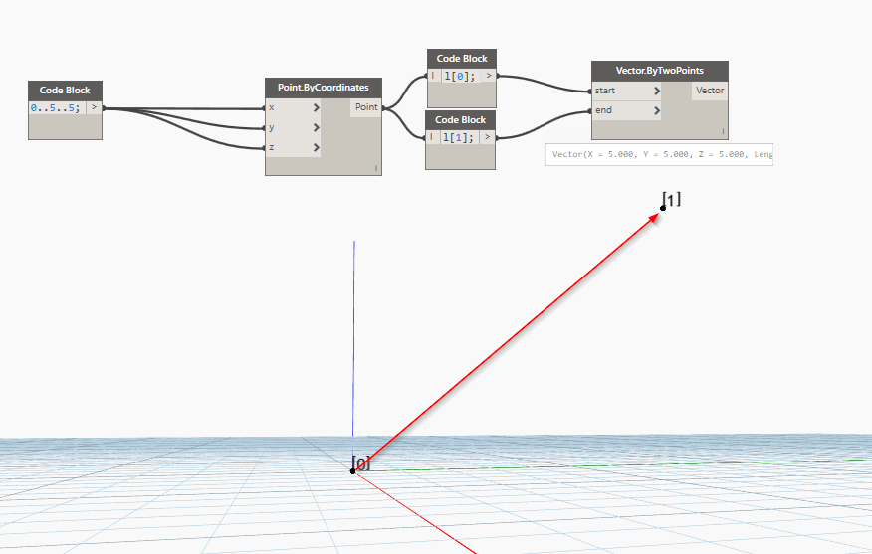

*Fig 3.3*

**3.2 Plane**

Plane is a flat surface that extends forever in two dimensions, but has no thickness. Most modeling software take advantage of construction planes or "levels" to define a local two-dimentional context to draft in. XY, XZ, YZ -or- North, Southeast, Plan might sound more familiar. These are all Planes, defining an infinite "flat" context. Planes don't have depth, but they do help us describe direction as well - each Plane has an Origin, X Direction, Y Direction, and a Z (Up) Direction.

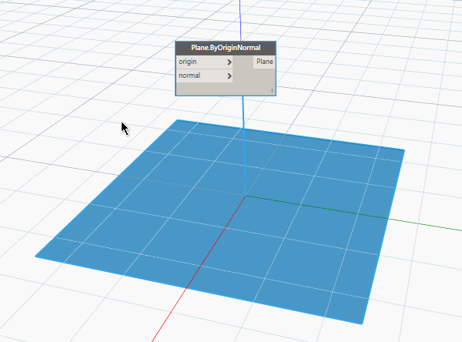

*Fig 3.4*

**3.3 Coordinate system**

The Cartesian coordinate indicate the position of points with respect to fixed point as reference and is the shortest distance from axes. In two-dimensional coordinate system, the fixed axes are the x and y axes and in three-dimensional coordinate system, the fixed axes are x, y, and z axes. For any coordinate system, the axes are perpendicular to each other and met at the fixed point is known as the origin. In other words, the Cartesian coordinates represent the location of a point which is at a perpendicular distance from two lines or three planes.

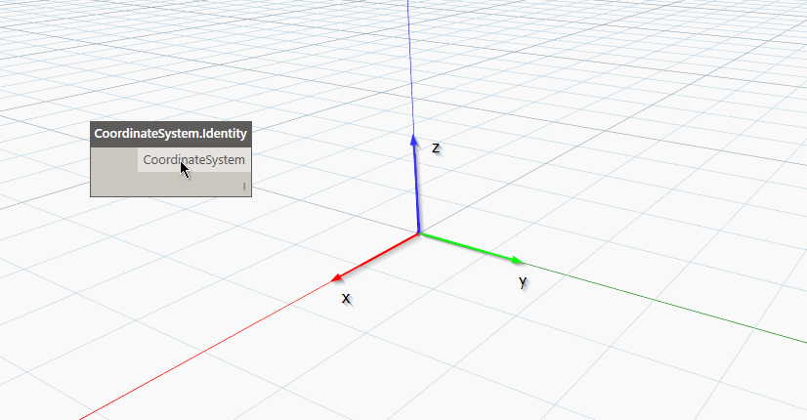

*Fig 3.5*

Vectors, Planes, and Coordinate Systems make up the primary group of Abstract Geometry Types. They help us define location, orientation, and the spatial context for other geometry that describe shapes.

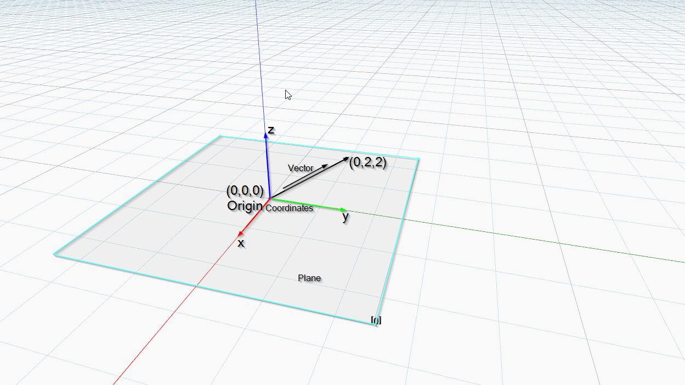

*Fig 3.6*

**3.4 Points**

Points are the foundation upon which all other geometry is created - we need at least two Points to create a Curve, we need at least three Points to make a Polygon or a Mesh Face, and so on. Defining the position, order, and relationship among Points (try a Sine Function) allows us to define higher order geometry like things we recognize as Circles or Curves.

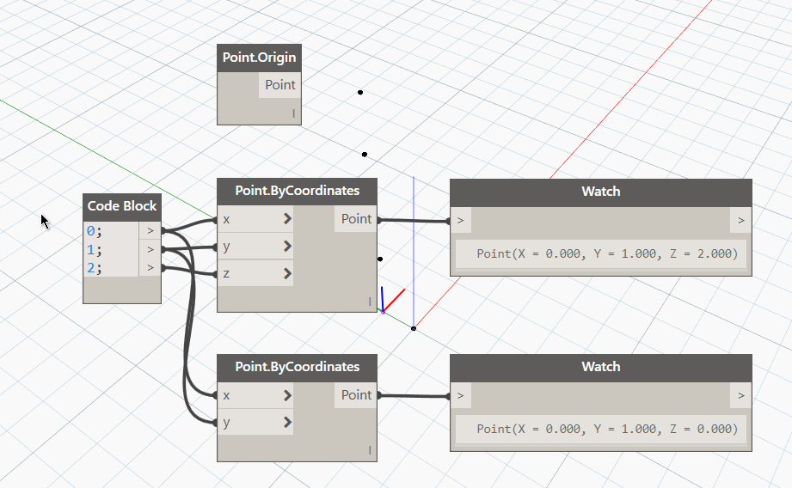

*Fig 3.7*

**3.5 Curves**

Curves are the first Geometric Data Type we've covered that have a more familiar set of shape descriptive properties. The **Curve** is generally a catch-all for all different sort of curved (even if straight) shapes. Capital "C" Curve is the parent categorization for all of those shape types - Lines, Circles, Splines, etc.

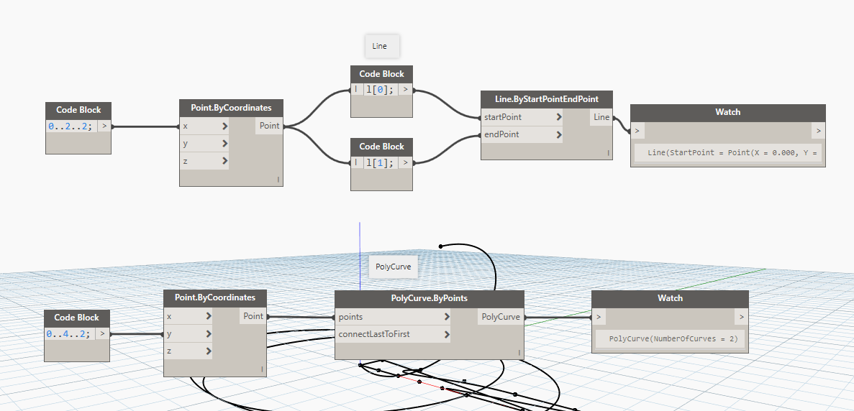

*Fig 3.8*

**Lines** are the simplest form of Curves. They may not look curvy but they are in fact Curves - just without any curvature. There are a few different ways to create Lines, the most intuitive being from Point A to Point B. The shape of the Line AB will be drawn between the points but mathematically it extends infinitely in both directions.

**3.6 Surface**

Surface, In geometry, a two-dimensional collection of points (flat surface), a three-dimensional collection of points whose cross section is a curve (curved surface), or the boundary of any three-dimensional solid. In general, a surface is a continuous boundary dividing a three-dimensional space into two regions.

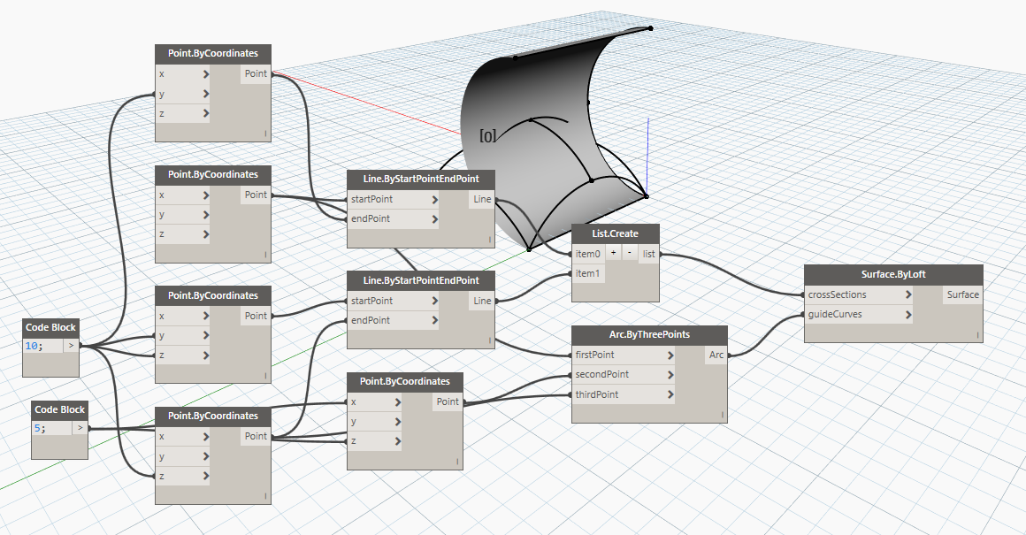

*Fig 3.9*

**3.7 Solids**

Solids can be created by joining Surfaces or Polysurfaces together or by using operations such as loft, sweep, and revolve. Sphere, Cube, Cone and Cylinder primitives are Solids.

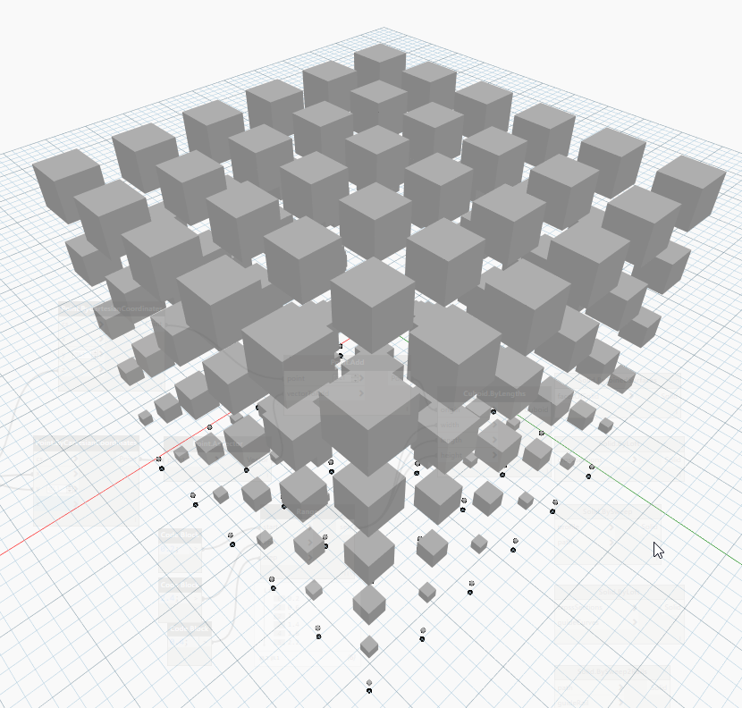

*Fig 3.10*

Solids are made up of three types of elements: Vertices, Edges, and Faces. Faces are the surfaces that make up the Solid. Edges are the Curves that define the connection between adjacent faces, and vertices are the start and end points of those Curves

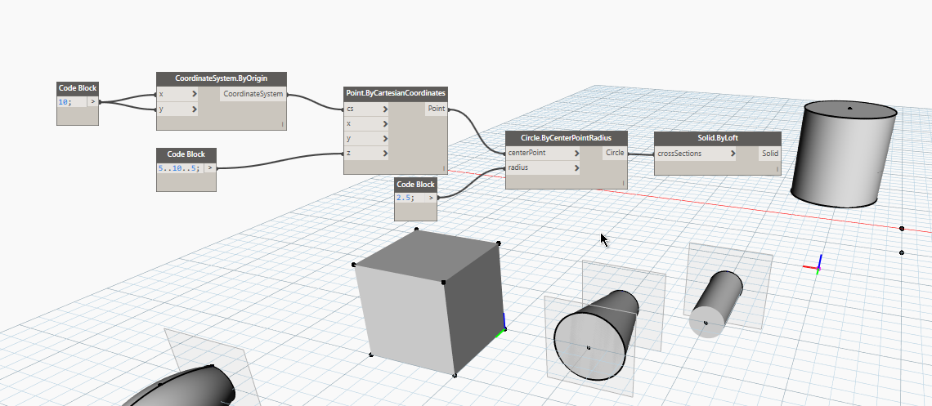

*Fig 3.11*

**3.7****Mesh**

A Mesh is a collection of quadrilaterals and triangles that represents a surface or solid geometry. Like Solids, the structure of a Mesh object includes vertices, edges, and faces.

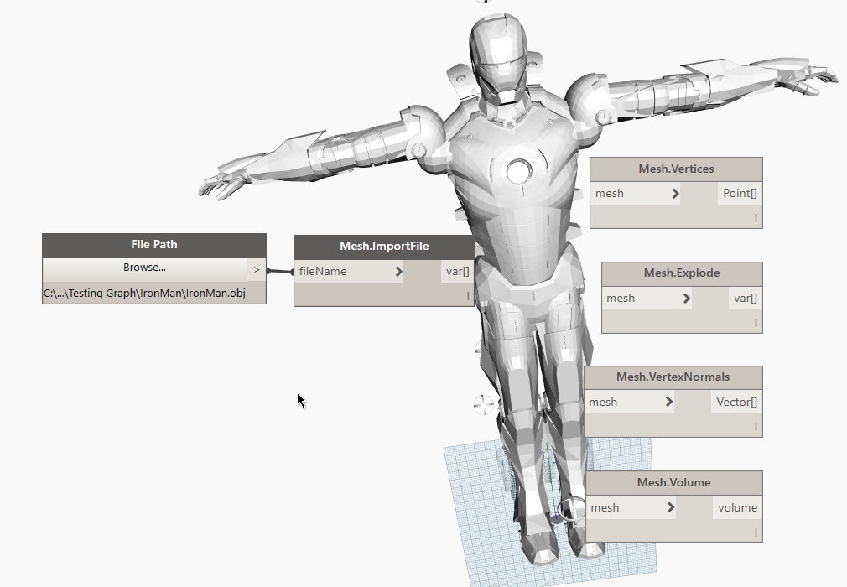

*Fig 3.12*

**REVIT DYNAMO**

Dynamo for Revit extends Building Information Modeling with the data and logic environment of a graphical algorithm editor. Its flexibility, coupled with a robust Revit database, offers a new perspective for BIM. However Dynamo done 80% of your work and the ramining work manually we shoud done because somewhere someplaces you need to modify on the spot may it is based on quality but the good news is work will done by accurate on time so that’s we say dynamo is one of the powerful tool and doing the voital role on BIM automatation.

* 1. **Selection**

The Selection Nodes are important one in dynamo because this is the one of the ways to get input from Revit and the nodes are directly contact with Revit application and These are Nodes are available for selection, and Select directly from the Revit by picking imports as geometry and element only and Select Directly from Revit import as Category, FamilyType, FloorType, ElementType, Levels, ColumnType, WallType and FramingType and it does not import as element and geometry so we need to convert.

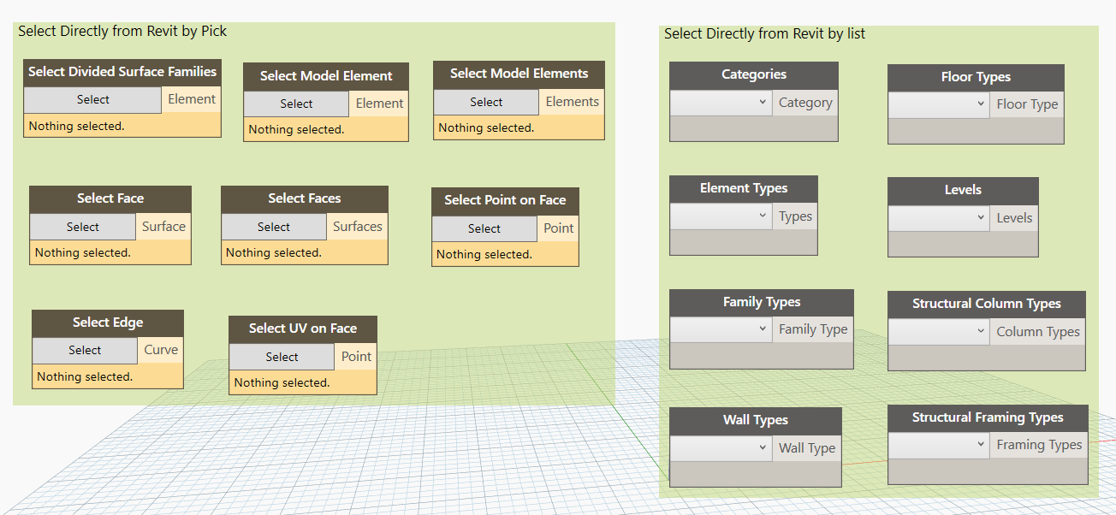 *Fig 4.1*

the selection action tools are converting as element type to element, category to element type, family type to element and levels to elements and the Revit hierarchy can be broken down into Categories, Families, Types and Instances it helps to understand how to use convert nodes.

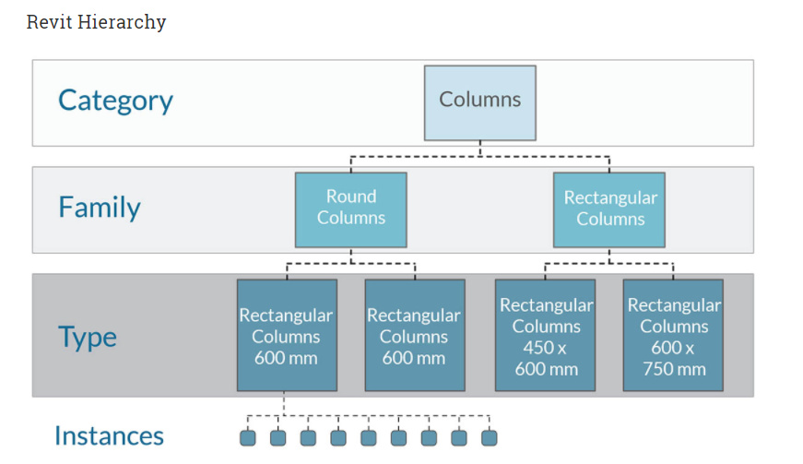

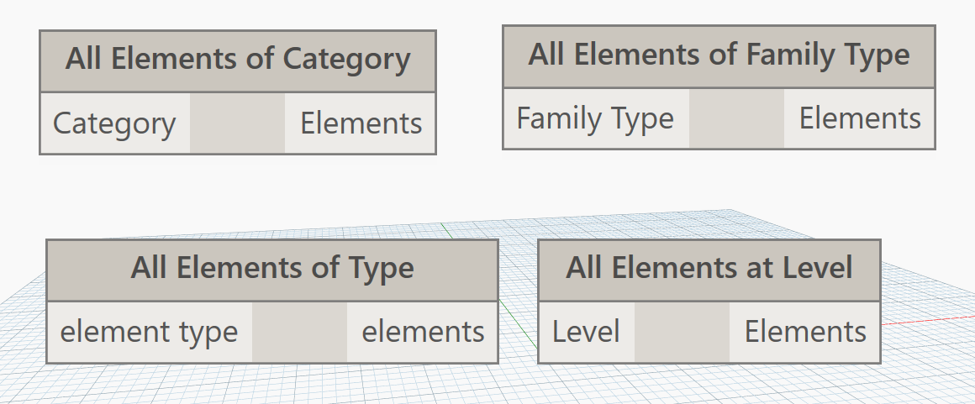

*Fig 4.2*

* 1. **Import**

Let’s discuss Import files from the external application because the external files are need to process sometime and it is not available in Revit imported file So, external file into dynamo use the File Path and which have a browse option for select your file. File Path node is only allowed to read and write the file it does not export as a file for example if you want to export sheet from dynamo to select the existing file.

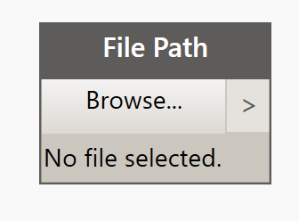

*Fig 4.3*

* 1. **Export**

Export from the dynamo use the directory path node to select path and it does allow to read or write a file.

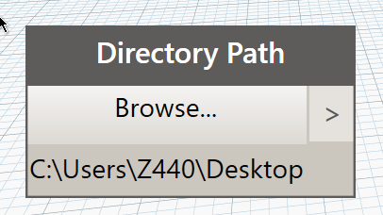

*Fig 4.4*

* 1. **Import and Export Excel Sheet into Dynamo**

Import and export Excels in dynamo have default nodes from the office in 1.x and import/export in 2.x these are nodes to access the Excel by Sheet via.

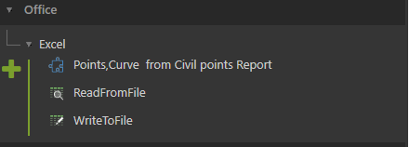

*Fig 4.5*

Read data from a Microsoft Excel spreadsheet. Data is read by row and returned in a series of lists by row. Rows and columns are zero-indexed; for example, the value in cell A1 will appear in the data list at [0,0]. This node requires Microsoft Excel to be installed.

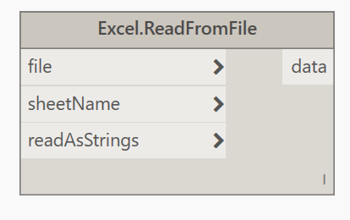

*Fig 4.6*

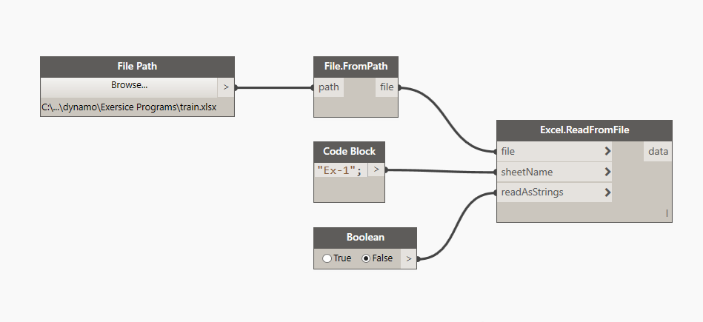

*Fig 4.7*

WriteToFile will return a List of Lists that is written to an Excel file. The sheet name, start row, and start column of where to write the data can be defined as inputs as well as whether existing data will be overwritten.

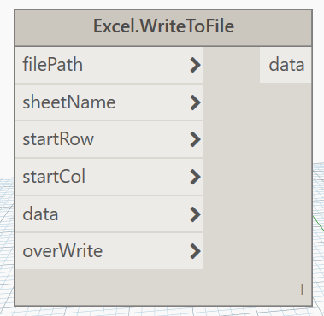

*Fig 4.8*

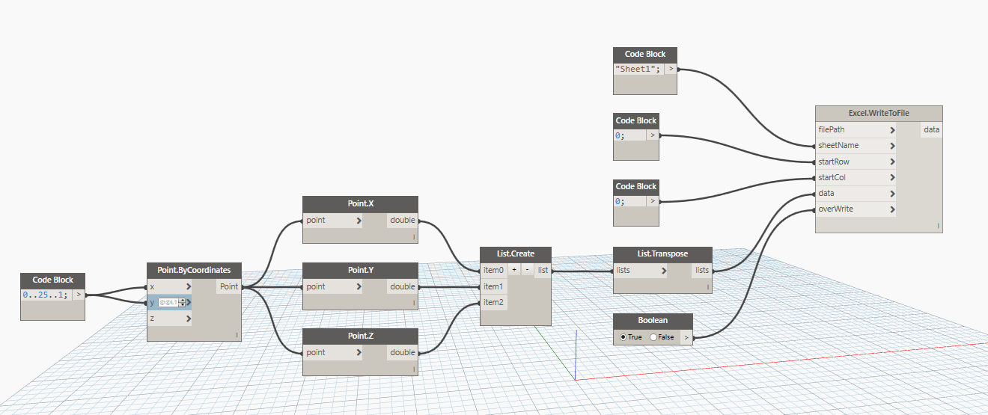

*Fig 4.9*

* 1. **Import CAD**

Importing CAD file into dynamo based on the two methods there are Revit Linked file into Dynamo and Direct import to dynamo, there is no nodes available from dynamo library like Read.CAD or ImportCAD So, we need to search External nodes from Package (Will Discuss in Next Unit) or OOTB.

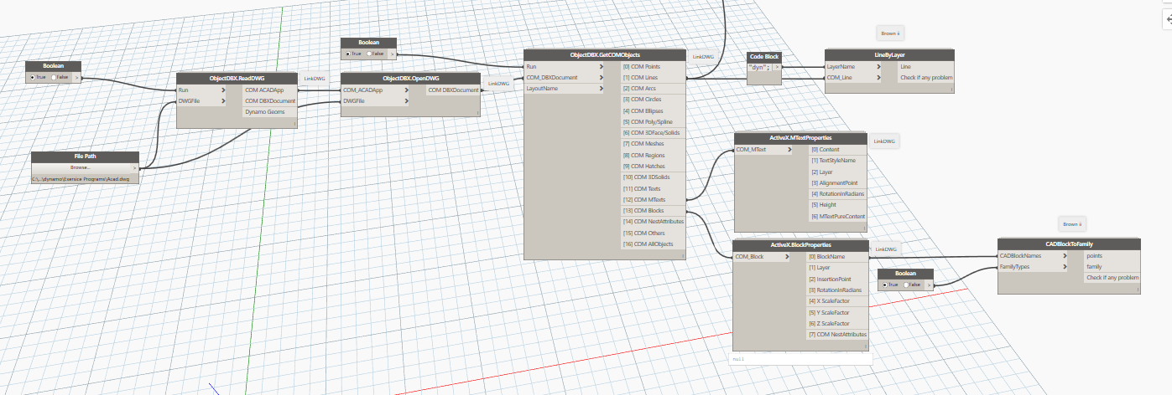

*Fig 4.10*

The LinkDWG Package is most recommended for importing CAD into Dynamo but it has some bug like when you are working with LinkDWG nodes in Dynamo you must to open the related CAD file in your Desktop and then the other many packages are available for importing cad into dynamo so search yourself to find the cad related nodes. Personally, I recommended BimporphNodes.

Purpose of importing Cad importing is reduce your work for modeling by creating wall, placing column, windows, door, furniture placing, MEP service and ect,.

* 1. **CREATE GRID**

Create gird is the simplest task and the node is available in Dynamo library and the Grid node is useful for defining large collections of grid elements from static inputs. Dynamically adjusting the Grid element's line parameters will create new elements and it create by ByArc, Byline and ByStartPointEndPoint. 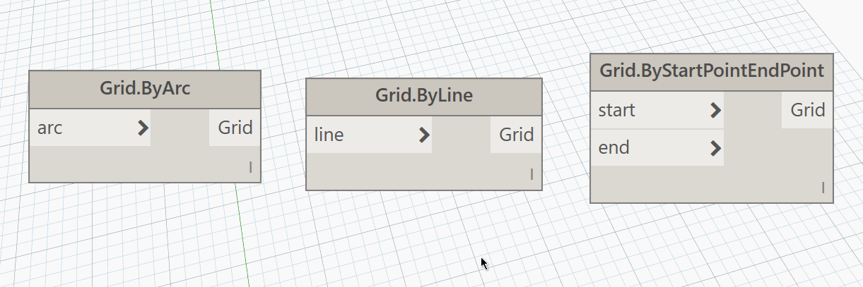

*Fig 4.11*

* 1. **Create Level**

Create Level is also simple task and node is available in Dynamo dictionary but does not required curves to form like a gird and it requires height or elevation values of levels and the Level node is useful for defining large collections of Level elements from static inputs and it create by four methods Level.ByElevationAndName, Level.ByElevation, Level.ByLevelOffset and Level.ByLevelOffesetAndName.

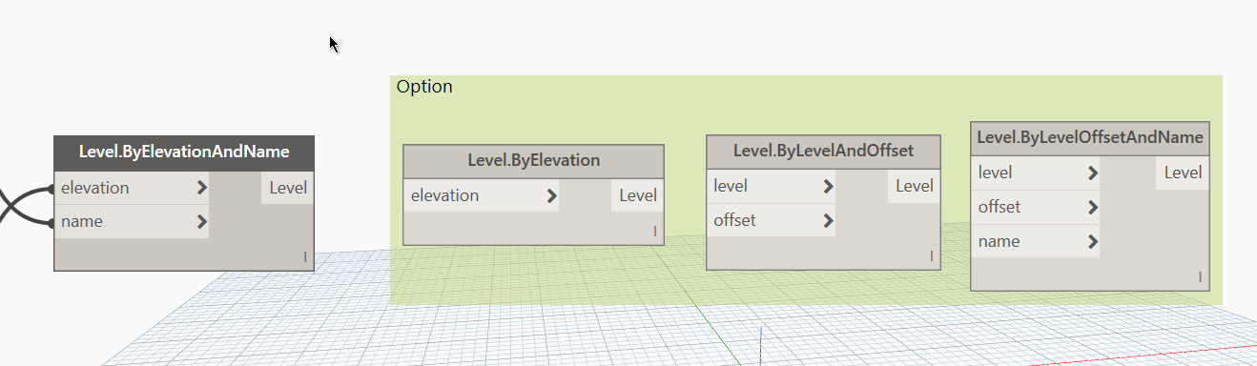

*Fig 4.12*

* 1. **Create Wall**

Create wall based on dynamo library there is two method to create wall there are Wall.ByCurveAndLevels and Wall.ByCurveAndHeight both are required curves to form a wall so if you have curve from cad file use these nodes to create wall

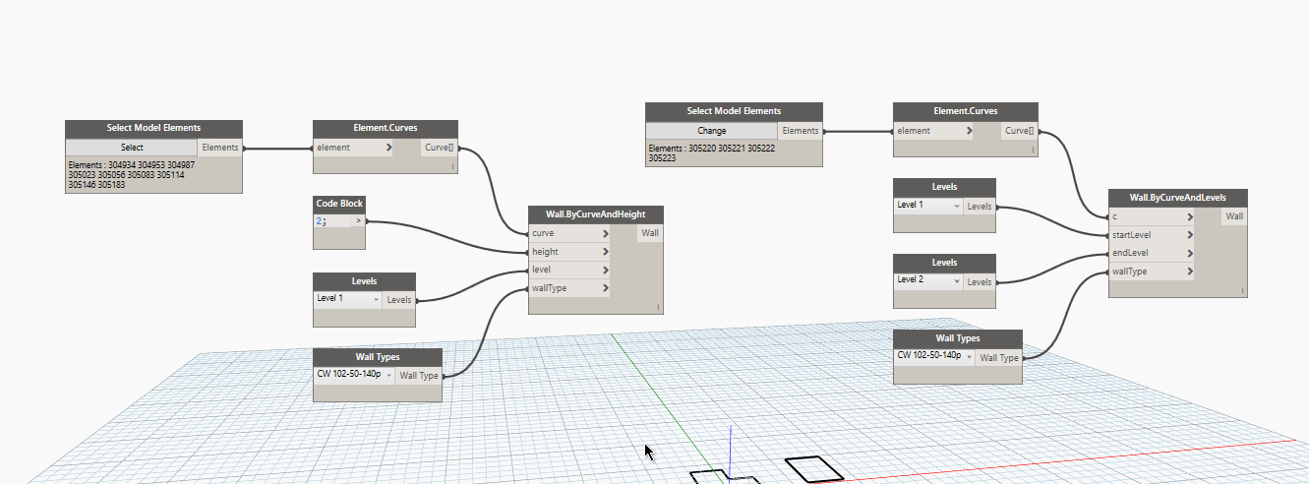

*Fig 4.13*

**4.9 Create Line Based Element**

Create line-based Element is similar as wall and many packages available like MEPover, Universo_BIM, Clockwork, GeniusLoci and etc., However, the elements should be linear in Revit modeling so need draw but in Dynamo we don’t want to draw for example if you have a layout drawing file that’s enough for accomplish the task then the nodes mostly required Element type like wall type so check your input if it is elements change into Element type else use element type node and other parameters are depends on the element like duct requires size, pipe requires diameter, conduits requires size..

Tips and Tricks

*The connector element like pipe connected by valves, tray supports and etc., are point element that means this all are family based element so use the end point place the relevant family.*

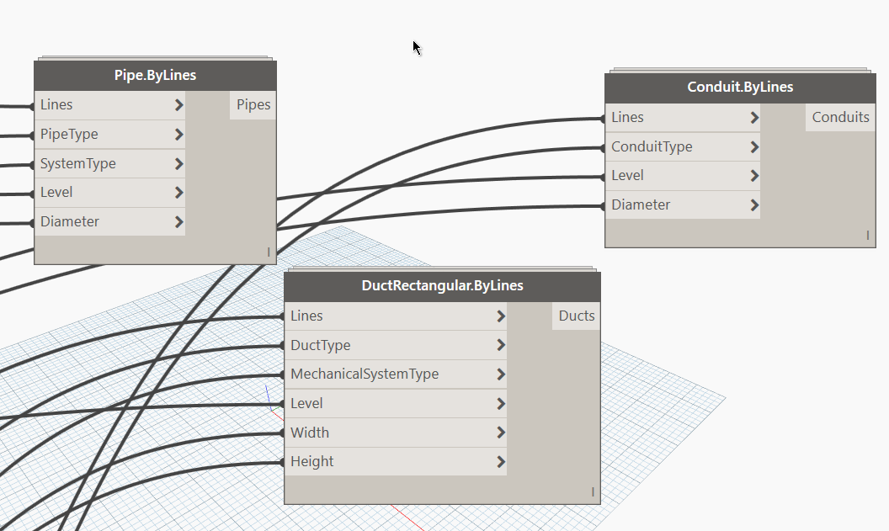

*Fig 4.14*

* 1. **Adoptive Components**

The Form Model is depending on the Conceptual model so this category Node is used on Conceptual mass family. Usually the Conceptual mass have Adoptive Points and profiles use the adoptive nodes to create the element then the Adoptive components are flexible to create in Revit and in dynamo is more convenient to practice and the nodes are available in Dynamo library and Packages.

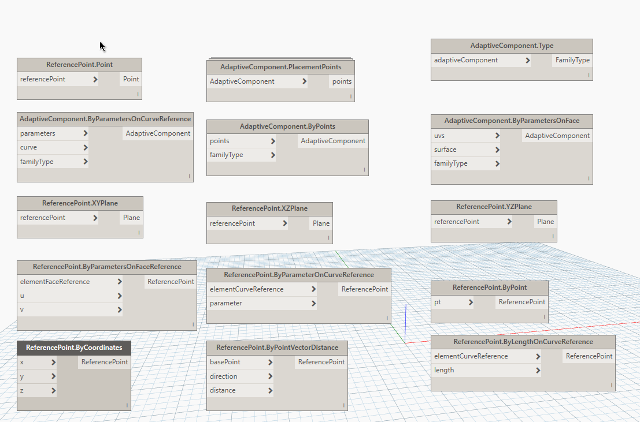

*Fig 4.15*

Adaptive components are complex for example tunnels, truss, facade and ect., however the nodes are generating the component, plane, reference point and Point.

* 1. **Get and Set Parameter**

All elements generally consist parameter in instance and type So to get the parameter value from the element use the GetParameterValue Node and to set the value into the element by use SetParameteValue. Those are commonly to get or set used for bulk of value from the elements for example in COBie Commonly get the parameter from one element like room name, number etc., and its set into another element like door. However, the nodes are available in Dynamo library and some additional packages also available.

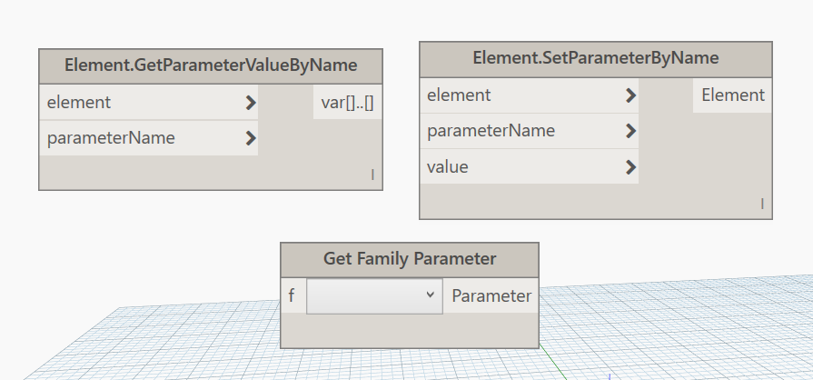

*Fig 4.16*

* 1. **Import Instance**

Before Import instance we should discuss the dynamo element and Revit element most commonly the Revit elements with their own id I mean each element carries element ID if you want check in dynamo use ElementId node or from Revit manage tab and the dynamo elements or geometry does not have ElementId so if you create any dynamo geometry need to import into Revit project then to change into revit element by Import instance. the Import instance is the one of way to import dynamo geometry to Revit element and this node is available in dynamo library.

ImportInstance.ByGeometry and ImportInstance.ByGeometries are similar but ByGeometries imports with revit element ID’s I mean each geometry carries element ID and the ByGeometry is import as single element ID I mean all geometry grouped into one element.

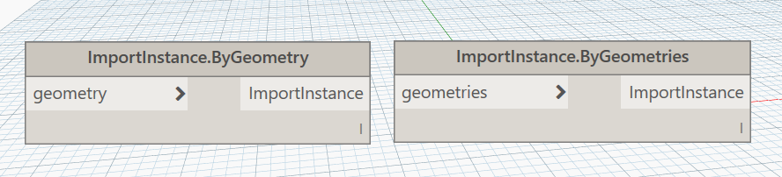

*Fig 4.17*

* 1. **ByGeometry**

The ByGeometry is very important node in Revit dynamo because if you are use the import instance it carries only the ElementId and does not categories an element and what type of element So to define a dynamo geometry is which category, material and name for import into revit and use ByGeometry node for this process it is available in dynamo library and package also available.

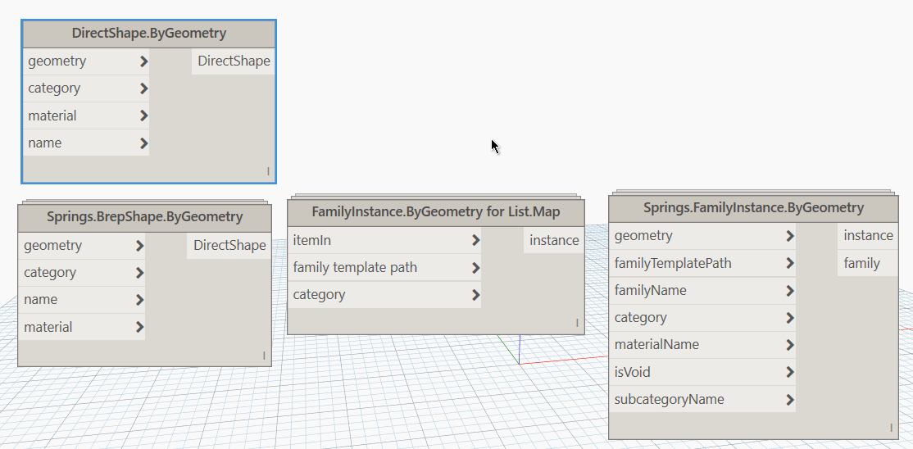

*Fig 4.18*

Tips and Tricks

*Use Spring node for edit type and smooth surface of geometry because generally the Direct Shape node is creating the geometry but it formed as mesh geometry and the spring node formed as smooth surface geometry*

* 1. **Create Sheet**

Create Sheet is required tittle block, sheet Name, Sheet Number and views this node are available in Dynamo library. When number of Sheet to be create with below nodes are recommended and the views are also have been place within the sheet, how ever the sheets are created with relevant views and tittle block family.

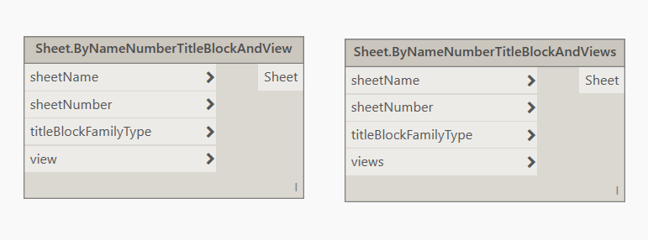

*Fig 4.19*

Tips and tricks

Use excel sheet for Sheet name and number and the views are manually set to the

**Package**

The Dynamo Package Manager is a portal for the community to download any package which has been published online. These toolsets are developed by third parties in order to extend Dynamo's core functionality, accessible to all, and ready to download at the click of the button.

* 1. **Add Package**

way to install a package is by using the Packages toolbar in your Dynamo interface

Step1:

Packages 🡪 Search for a Packages

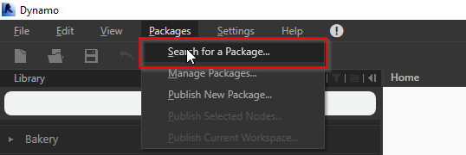

*Fig 5.1*

Step2:

Download current package version from search result and below versions are available inside the package the search result.

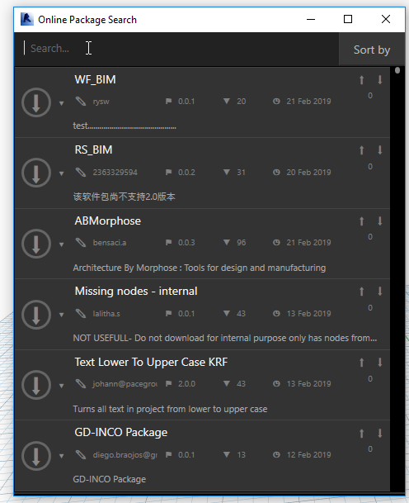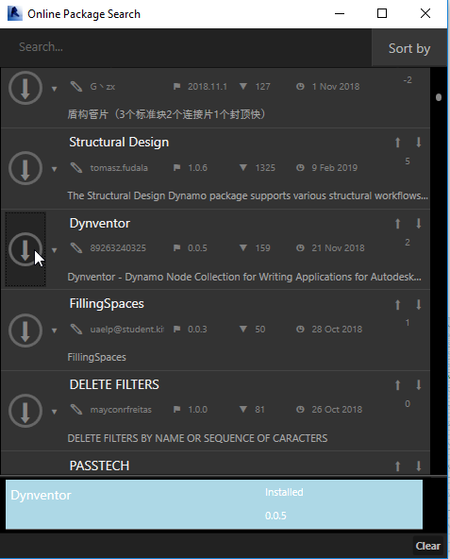

*Fig 5.2*

* 1. **Download Package zip**

Packages can directly download from the <http://dynamopackages.com/> and the packages are zip file so require to extract and paste into the root folder. Lets discuss how to download and paste into root folder.

Step 1:

Go to <http://dynamopackages.com/> site or  from manage package and search from package manager and most popular packages, most recent updated packages are categorized.

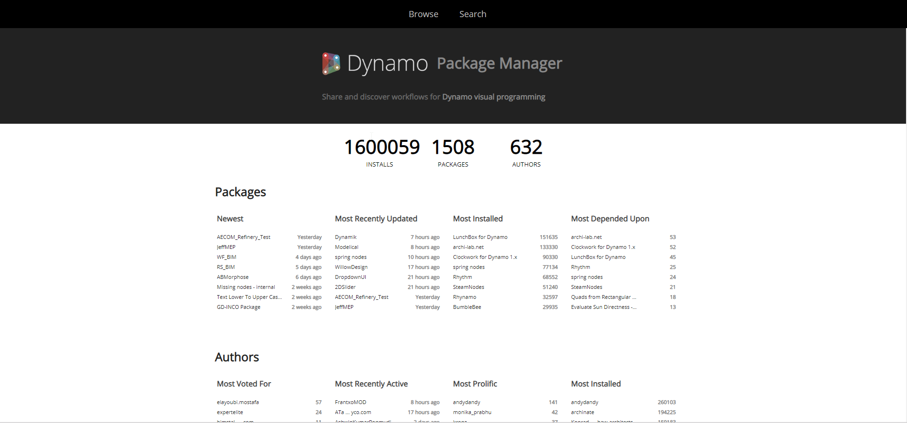

*Fig 5.3*

Step 2:

Directly download the package and below versions also available from the download list.

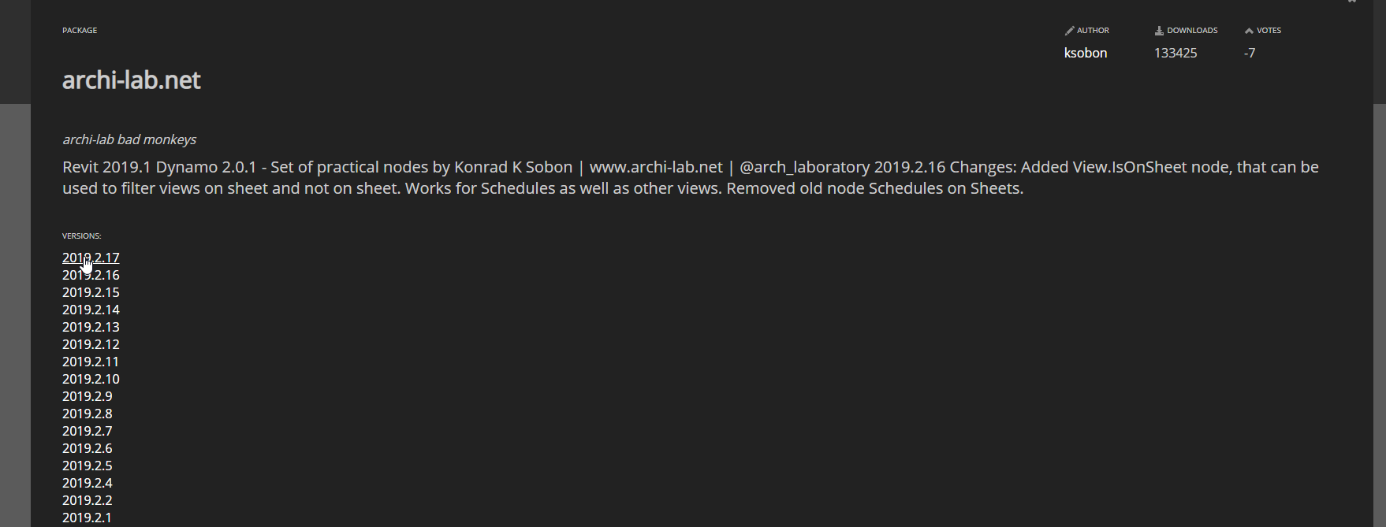

*Fig 5.4*

*Step 3:*

Zip file contains bin, dyf and extra folder and pkg.json file, however just copy folder and file

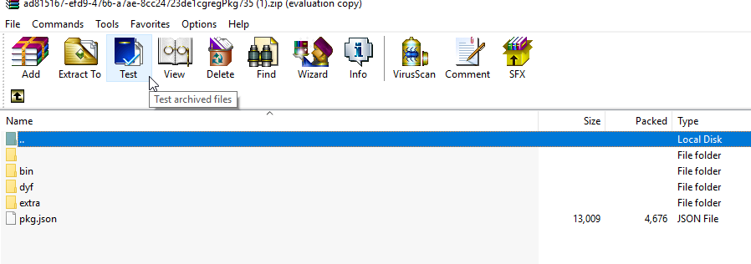

*Fig 5.5*

*Step 4:*

Go to root folder *“C:\Users\XXXX\AppData\Roaming\Dynamo\Dynamo Revit\1.2\packages”* and create folder from there then paste the copied files

*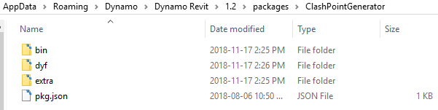 Fig 5.6*

Then the package is available on dynamo, this is another way to add package into dynamo.

* 1. **Manage package**

Manage package consist installed packages so we can uninstall, access root directory, nodes contents, publish package and package versions from the manage package

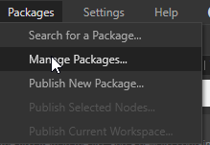 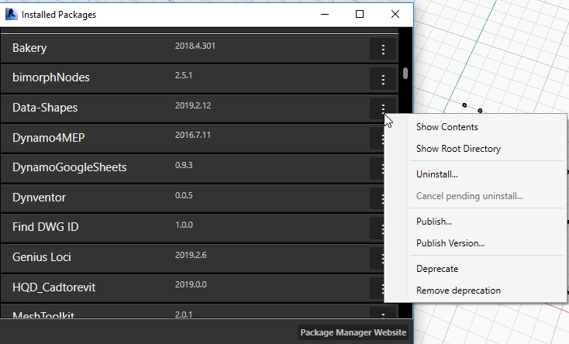

*Fig 5.7*

* 1. **5.4 Recommended Packages**
* ClockWork
* DynamoMEP
* MEPover
* Universo_BIM
* Zhukoven
* Modelical
* Archi-lab
* LunchBox
* BimorphNodes
* LinkDWG
* Bakery
* Data-Shape
* Rhythm
* Springs

**MODIFY**

**6.1 Node Status**

The node status is the study of node and it is behavior for example if the node freeze condition which has doted layout and transparency and if the node in preview off condition which is dark gray color, however the nodes status depends on the properties and you can modify the properties by select the node and right click which shows the properties

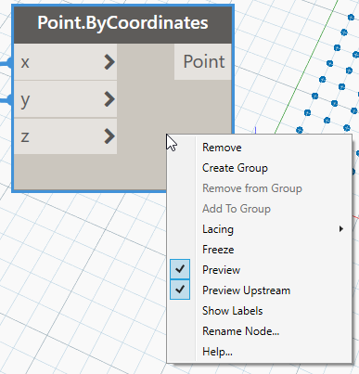 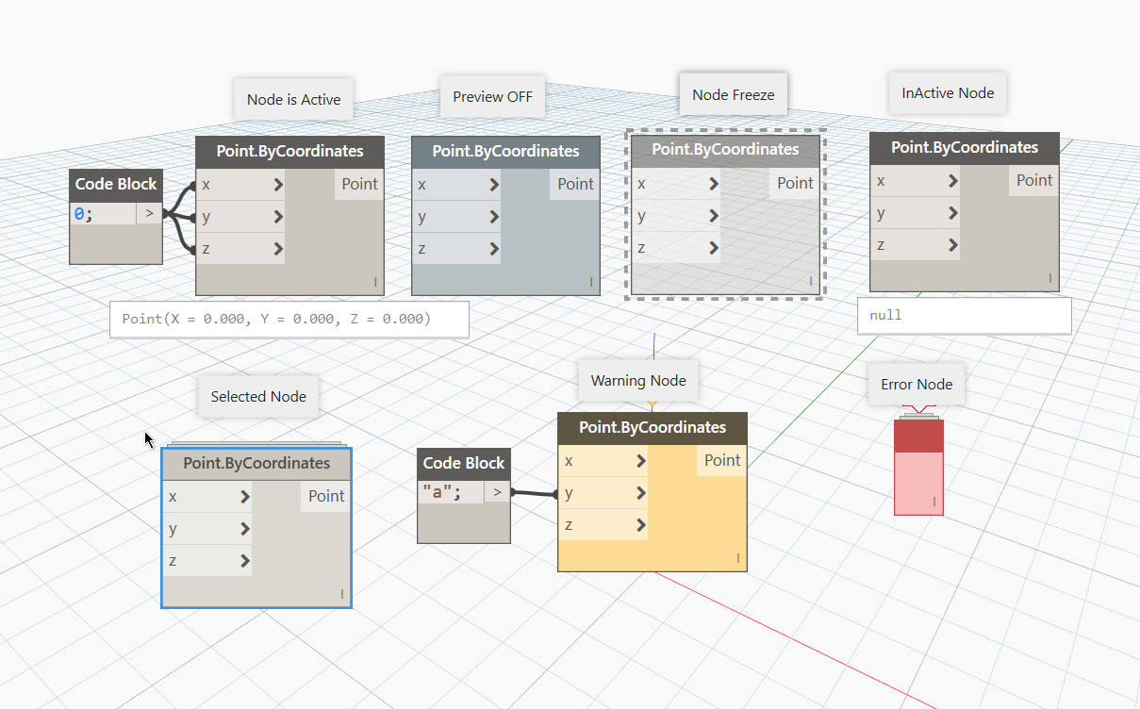

*Fig 6.1*

**6.2 Node to Code**

Node to code is the one of option to know the conditions ofdynamo node Let's demonstrate that select dynamo node for example Point.ByCoordinates and right click on workspace not in node as shown in fig 5.8 and the node is modified into Code block and one more thing this node to code is applicable for certain dynamo nodes only.

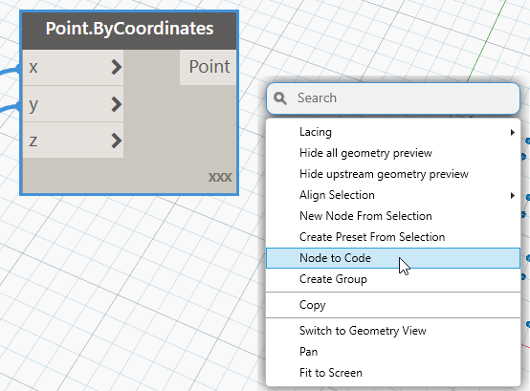 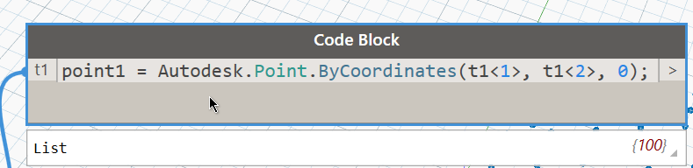

*Fig 6.2*

* 1. **Unwarp Nodes**

Node unwarping is applicable for certain nodes only based on python basis node or combined nodes are to formed as node is only can unwarp and based on C# basis node or dynamo default node can’t be unwarp, however let’s discuss how to unwarp which is similar as node to code but procedure is vary Select node 🡪 right click🡪 Edit custom node or double click the node.

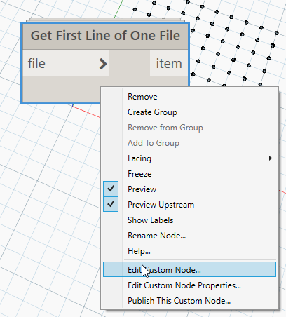

*Fig 6.3*

* 1. **KEYBOARD SHORTCUTS**

This are the shortcut keys for dynamo and there is no custom keyboard shortcut.

* F5 … Run Workflow
* Ctrl + - … Zoom out (not on numeric keypad)
* Ctrl + = … zoom in (not on numeric keypad)
* Ctrl + A … select All
* Ctrl + Alt + Down … Pan Down
* Ctrl + Alt + Left … Pan Left
* Ctrl + Alt + Right … Pan Right
* Ctrl + Alt + Up … Pan Up
* Ctrl + B … navigate Background 3D preview
* Ctrl + L … cleanup node Layout
* Ctrl + N … new home workspace
* Ctrl + O … Open
* Ctrl + S … Save
* Ctrl + Shift + N … custom node
* Ctrl + Shift + S … SaveAs
* Ctrl + Shift + Up … show Console (on or off toggle)
* Ctrl + T … create preset from selection
* Ctrl + U … Ungroup
* Ctrl + W … create Note
* Shift + R Click … Add to Group (click on group first)
* Ctrl+0: Zoom on current block
* Select node + Ctrl +left mouse drag - copies that node
  1. **NODE GROUP AND WRITE NOTE**

Node grouping is set of from into a group within the box the purpose of the grouping understanding the graph idea and segregate the operations of graph which allow to write the nodes about the group appeared in top left, however we can also write the notes by use notes option from view or Ctrl+w which is used for user understating the graph and node by written notes.

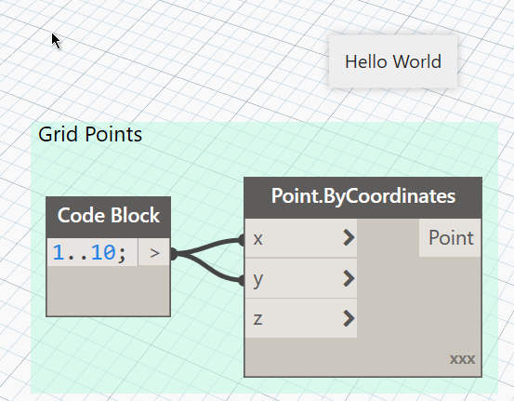

*Fig 6.4*

* 1. **LEVELS**

Levels is the option to access the listed input, before to discuss the levels we should discuss the list address (@L) the list addressing is mentioning the location to read for example triple nested list like  which have three list in output so read the list element use @L1 if to read the secondary list @L2 means which contain only element and if to read nested list @L3 it means which contains list and elements. So, use method set the levels for the node for example last output node nested list and the input node to read the @L2 for the output so to set levels by use levels option as shown in fig.

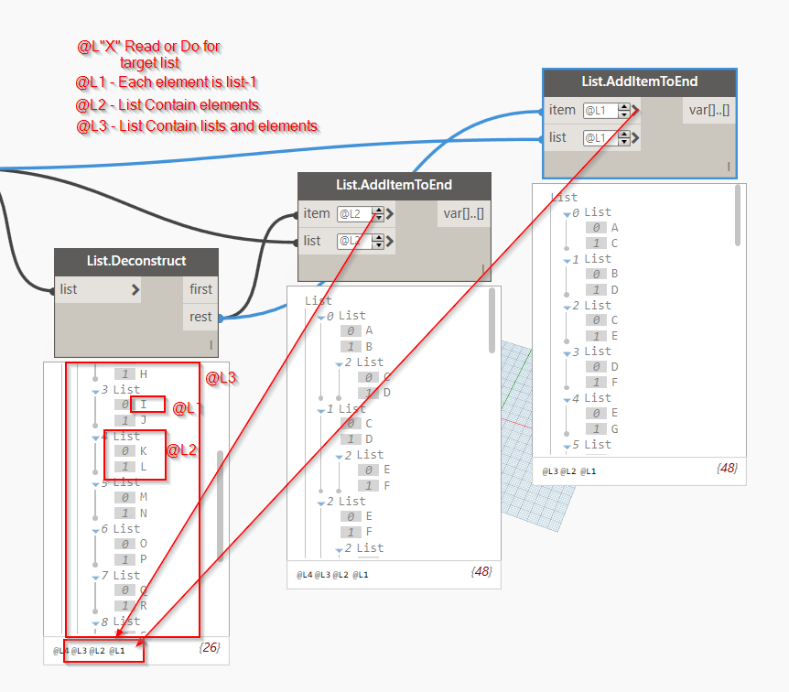

*Fig 6.5*

* 1. **LACING**

Data matching is a problem without a clean solution. It occurs when a node has access to differently sized inputs. Changing the data matching algorithm can lead to vastly different results.

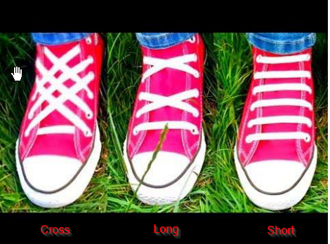

*Fig 6.6*

Shortest List

The simplest way is to connect the inputs one-on-one until one of the streams runs dry

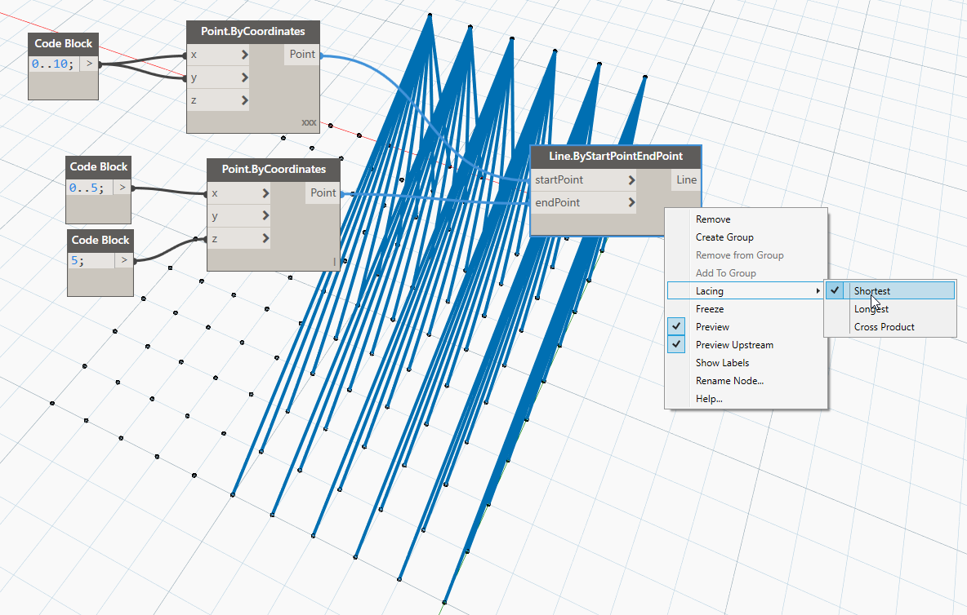

*Fig 6.7*

Longest List

The “Longest List” algorithm keeps connecting inputs, reusing elements, until all streams run dry

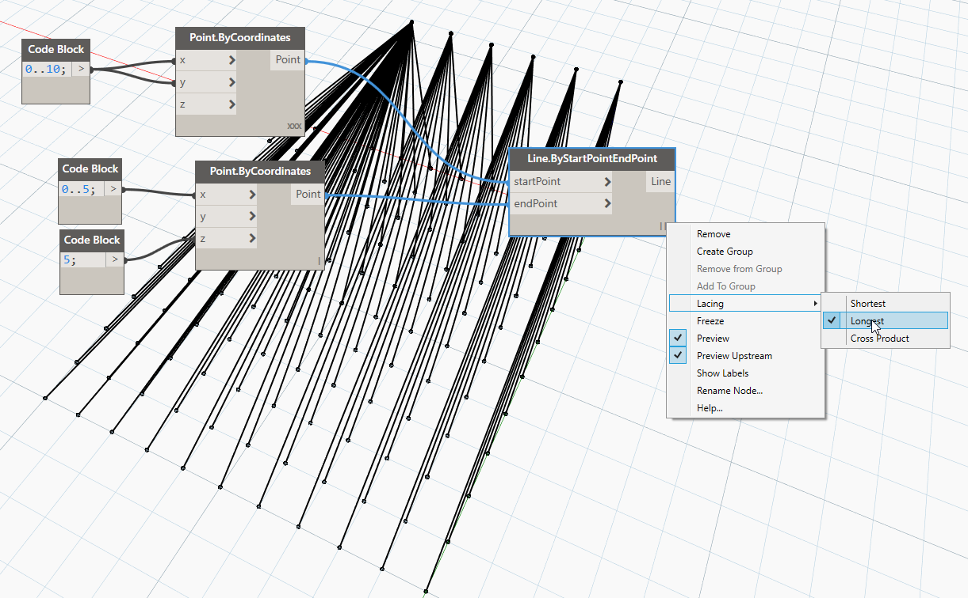

*Fig 6.8*

Cross Product

Finally, the “Cross Product” method makes all possible connections

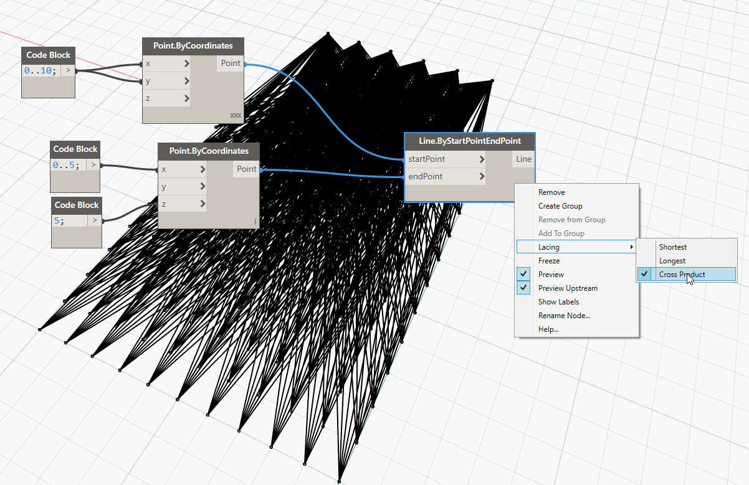

*Fig 6.9*

**DESIGN SCRIPT- (ADVANCE LEVEL)**

The DesignScript has been created to express design intentions.

It is generally recognized that computational designing is exploratory, and Dynamo tries to support this: we hope you find the language flexible and fast enough to take a design from concept, through design

iterations, to your final form.

This topic to give a user with no knowledge of either programming or architectural geometry full exposure to a variety of topics in these two intersecting disciplines.

Individuals with more experienced backgrounds should jump to the individual sections which are relevant to their interests and problem domain.

DesignScript, used inside of the Dynamo editor (sometimes referred to as “Dynamo Sandbox”).

To create a new Dynamo script, open the Dynamo editor, and select the “New” button in the “FILES” group:

This will open a blank Dynamo graph. To write a Dynamo text script, double click anywhere in the canvas. This will bring up a “Code Block” node. In order to easily see the results of our scripts, attach a “Watch” node to the output of your Code Block node, as shown here: